LECTURE ONE
QUESTIONS TO BE ANSWERED:
- What is economics to a layman?
- What are the challenges?
- Is progress rational?

We are economists as we decide and operate (workings of an economist)
Economics: Economics is the allocation of scarce resources amongst the alternative ends to meet unlimited wants.

TYPES OF ECONOMICS
Positive Economics: Focuses on objective, fact-based statements about the economy that can be tested and validated. (facts and figures, it is)
Normative Economics: Involves subjective, value-based judgments about what the economy should be like (emphasizing the problems and trying to find solutions, should be/must be)
Policy Economics: The application of economic principles to develop policies to improve economic outcomes. They are the problems reported and remedies prepared to address the issues

Positive (problems reported) + Normative (problem remedies/policy) === Policy economics

BASIC KEY TERMS
Trade-off: The opportunity you chose in the present that caused an opportunity cost. Trade-offs can be a matter of choice or compulsion.
Opportunity-cost: what was given up for the trade-off.
(Example: For POE(trade-off), FOM(opportunity-cost) was given up)
Resources: Things around us used for production and distribution to make our trade-off work. (never enough)
Scarcity: The gap between the need list (finite, tradeoff) and the want list (infinite, opportunities). Scarcity becomes the ultimate challenge for economists. It also means to try to find the best of ourselves and the things around us.

Need-list | Want-list
Necessity | Desire
Priority | Flexible
Absence leads to major impacts | Absence causes minor impacts.

EXAMPLE OF TEACHERS:
Opportunity cost: A teacher giving up personal free time/sleep
Trade-off: Choosing to spend time in the classroom teaching instead of doing administrative tasks.
Resources: Using a projector, whiteboard, and textbooks to teach students.

Resource Categories:
- Land (endowed by nature, it’s there to be utilized)
- Labor (physical and mental)
- Capital (Not money but the equipment, and infrastructure, that generates economic activity and individuals are compensated)(Land + Labor)
- Enterprise/entrepreneur (Risk takers, creative heads that add value, innovators, not necessarily with money but with ideas)
Value added = Output - Input

What an economist does:
- Decision-making
- Manage scarcity
- Get the best from what is available
- Rationalize a decision as long as it doesn't barricade anything
- Know about purchasing power, needs, wants, and choices.
Working like an economist:
- To manage limited resources
- To get the best from what is available
- To rationalize the decision made as long as it does not barricade anything (logical)
We should know our:
- Purchasing power
- Needs
- Wants
- Choices (determined by incentive)

Purchasing-power: The ability to buy.
Choices: Decisions made when faced with trade-offs. They are determined by incentive
Market: A platform where buyers and sellers make choices(rational or irrational) based on incentives.
Incentive: Agreement between buyer and seller termed as price/benefits or costs of an action influencing people's decisions and behavior (gpb.org). Incentives are important to economics for two reasons: how people respond to them and how they are created and used.
Rational Choices: Maximize utility and profit.
Irrational Choices: Decisions that do not align with economic theories of rationality. This could be due to emotional factors, biases, lack of information, or other influences that lead to make choices that do not maximize their utility or profit.

EXAMPLE:
Rational decision: A buyer selects the best smartphone within their budget based on features and price.
Irrational decision: A buyer purchases an overpriced smartphone due to brand loyalty despite better, cheaper options.

Progress is considered rational if it leads to improvements in well-being, efficiency, or utility based on logical decision-making. However, it can be irrational if driven by short-term gains or emotional factors that overlook long-term consequences.

How does it all fit together? (ChatGPT)
- In a well-functioning market, buyers and sellers interact through their decisions, which are influenced by rational and irrational factors. Choices are made based on available options and incentives, which in turn affect supply and demand.
- Rational decisions aim to maximize benefit or profit, while irrational decisions might deviate from these goals due to various influences.
- Incentives play a crucial role in shaping these decisions, guiding how buyers and sellers respond to changes in prices, availability, and market conditions.

Overall, the market is a dynamic system where the interplay between buyers and sellers, guided by their decisions and incentives, determines the allocation of resources and the flow of goods and services.

Key Terms

trade-off | opportunity | resources | opportunity-cost | scarcity
need-list | want-list | choices | incentives | rational
irrational | purchasing-power | buyers | sellers | positive eco
normative eco | Policy eco | finite | infinite | land
labor | capital | enterprise | entrepreneur

LECTURE TWO
Summary of Economics From previous Lecture:
- Economics is about the allocation of scarce resources amongst the alternative ends to meet unlimited wants (scarcity-based)
- Economics is the study of how humans consume and industries produce and how well both connect (consumption/production-based)
- Economics is the study of humans in different environments (environment-based)
- Economics is the study of how to create the best environment with the resources around us (environment/resource-based)
- Economics is the study of how to put things around us to the best use (resource-based)

Scarcity-Based: Focuses on resource allocation due to limited availability.
Consumption/Production-Based: Looks at how consumption and production processes are managed and interconnected.
Environment-Based: Considers economic behavior within and impact on different environments.
Environment/Resource-Based: Aims at creating optimal environments through effective resource management.
Resource-Based: Concentrates on the efficient use of resources to achieve economic objectives.

Policy: Framework, statement, structure. A policy should continue or else there is chaos.

TYPES OF POLICIES
Fiscal Policy: Framed by government. Include government support/spending, taxes and investment. Formed by the parliament, the government and the social and economic conditions.
- Objectives: economic growth, stability and equity.
- Example: During a recession, the government increases infrastructure spending and lowers taxes to boost jobs and consumer spending.
- Formation process:

- Parliament: Reviews and approves the budget, including the increased spending and tax cuts proposed by the government.
- Government: Develops the budget proposal based on current economic conditions and policy objectives.
- Social and Economic Conditions: The policy responds to high unemployment and low consumer spending, aiming to boost economic activity and job creation.
Further Reading: Fiscal Policy

Monetary Policy: Framework formed by the central bank, state bank, or reserve bank. The framework depends on money supply, interest rates (cost of borrowing), borrowing, and spending.

Money supply = Currency (cash in hand (paper or plastic) ) + Deposits (cash in bank)

- The more the deposit, the more the money supply.(direct proportionality)

Money Supply ∝ Deposits
Interest Rate 1/∝ Money Supply (borrowing is low)

- If the interest rate is high, money supply is low, because borrowing is low (inverse proportionality).
- In theory if there is more money supply, there is more production and so more employment(good economic state).
Further Reading: Monetary vs Fiscal

Foreign Policy: Policies regarding maintaining relations with other countries, covering political, social, and economic aspects (bilateral and trilateral).
Examples:
- Pakistan to India: (rival)disturbed relations.
- Pakistan to China:(ally)policies relating to partnerships.
- Pakistan to USA:(indebted to)policies relating to loans.(Umbrella of USA)
- Pakistan to EU:(target market)policies relating to exports.

SAARC(South Asian Association for Regional Cooperation):About SAARC
Further reading: EU foreign role in SAARC

Scientific Models:
- Set hypothesis (assumptions based on observation)
- Create an isolated environment(so that only independent and dependent variables are affected).
- Experiment
- Record results
- Evaluate

Economic Models: Simplified versions of the reality to explain the complex situations.

TYPES OF ECONOMIC MODELS
Demand Model: Dependent on price, which is inversely proportional to demand. Price influences buyer behavior and is also known as an incentive.
Demand: Desire and willingness to buy goods and services at different prices.

Price 1/∝ Demand

Supply Model: Dependent on price, which is directly proportional to supply. Price influences seller behavior, with profit as the main motivation.
Supply: Desire and willingness to produce the goods at different prices.

Price ∝ Supply

FALLACIES

Fallacies: Misleading statements (sometimes true, sometimes false).
Indifference: Neither agree nor disagree.
Fallacy of Composition: Appears to be true for one person may not be true for all.
Punctuality Fallacy: Believing that strict adherence to being on time is always essential or a sign of competence.
Healthcare Fallacy: Assuming that a specific healthcare treatment is universally effective for everyone.
Divine Fallacy: Assuming something is true solely because it is considered divine or sacred.

Key Terms

Value added | Output | Input | Fiscal policy | Monetary policy
Foreign policy | Currency | Deposit | Interest Rate | SAARC
Demand | Supply | Fallacy | Economic Model

LECTURE THREE

Rationality: Means logic; it also means a systemic framework to achieve the objective, as long as it doesn’t barricade anything.
- It is rational for a business to run after profit.
- It is rational for an individual to maximize satisfaction.
- Scenario example: A manufacturing company improves profit margins by analyzing costs, investing in efficient machinery, renegotiating supplier contracts, and adjusting as needed to reduce production costs while maintaining product quality.
- Creating a monopoly is considered rational for the firm holding it as it maximizes profits, benefits from economies of scale, and provides market control and stability.

Basic Questions in Economics

Q1) What to produce?
Dependant on essentials/luxuries, needs/wants

Q2)How to produce?
Dependent on resources,factors of production

Q3)When to produce?
Dependent on timeframe (events/festivities/season)

Q4)For whom to produce?
Dependant on market segments(dependent on location, income bracket, affordability)

Microeconomics: study of individuals and firms, maximizing utility and profit in a confined framework.
- Demand and supply
- Utility analysis
- Profit competitors
- Monopoly
- Cost of production

Macroeconomics: study of the entire economy.
- GDP,GNP
- Unemployment
- Inflation
- Exchange rate
- Banking
- Macroeconomics models

Utility: Happiness, usefulness, or satisfaction—the ability of a good or service to fulfill a person's wants or needs. It is intrinsic and cannot be measured directly.
Types: Total and marginal.
Profit = Revenue - Cost

Gross Domestic Product (GDP): Total production of goods and resources within the borders of a nation during a fixed period of time (e.g., a fiscal/financial year from July 2023 to June 2024).
Gross National Product (GNP): Production within and outside the borders of the country.
Unemployment: Lack of jobs and opportunities
- Involuntary: Qualified and skillful individuals but with not enough opportunities.
- Voluntary: Choice.
Inflation: Rise in price levels
- Good: Increased production + more opportunities + rising prices.
- Bad: No increase in production + no opportunities + rising prices.
Exchange Rate: Measurement of domestic currency in terms of foreign currency. If the nation’s exchange rate is positive, its economy is on the right path, otherwise it isn’t.
Banking: To bank means to trust
Assets | Liability
Reserves | Deposits
Types of Banking:
- 100% reserve banking
- Fractional banking(Mostly Used)
- Islamic banking

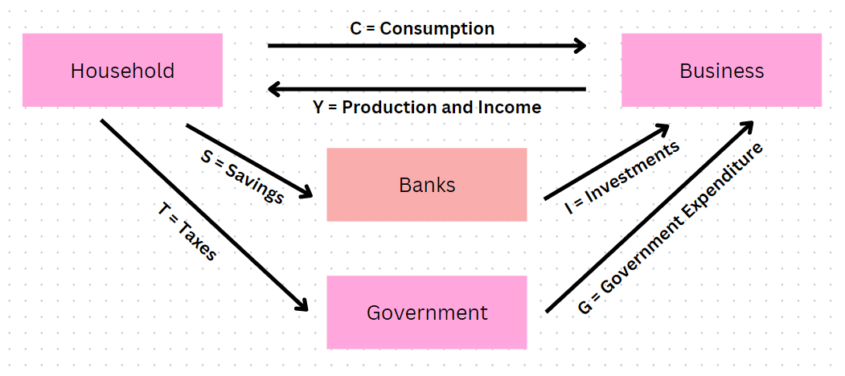
Circular income flow model for a closed economy: Perfect balance of a self-reliant closed economy. Self-reliance means that the economy does not engage in imports or exports.
(services)
(support)

Y = S + C + T
Y = C + I + G

Key Terms

Rationality | Monopoly | Market Segment | Timeframe | Utility
Microeconomics | Revenue | Cost | Macroeconomics | GDP
GNP | Unemployment | Inflation | Exchange Rate | Banking
Assets | Liability | Reserves | Deposits | Savings
Taxes | Income | Consumption | Investment | Self-reliance
Closed Economy | Circular Income Flow | Fiscal Year | Financial Year

LECTURE FOUR

CONSUMER BEHAVIOUR AND UTILITY MAXIMIZATION

Assumptions:
- Rationality: utility maximization and profit maximization in a logical and systematic theme
- Preferences: To prioritize the order of things and choices/ interest levels.
- Prices: cost, money paid for exchange and incentive.
- Budget Constraints:
- Income
- Budget line, price line

Let A = good1, B = good2

Income = (Price of A * Quantity of A) + (Price of B * Quantity of B)

Utility: Happiness, usefulness, or satisfaction—the ability of a good or service to fulfill a person's wants or needs. It is intrinsic and cannot be measured directly.
- Marginal Utility: Extra utility obtained by a repeated action. For example: rewatching a show.
- Total Utility

Law of Diminishing Marginal Utility
As an individual consumes more of a good or service, total utility increases, but marginal utility decreases.

- Repeated action = decreased marginal utility

Utility maximization:
(UTIL) → unit of utility

Tacos Consumed per unit | Total Utility\utils | Marginal Utility\utils
0 | 0 | 0
1 | 10 | 10
2 | 18 | 8
3 | 24 | 6
4 | 28 | 4
5 | 30 | 2
6 | 30 | 0
7 | 28 | -2

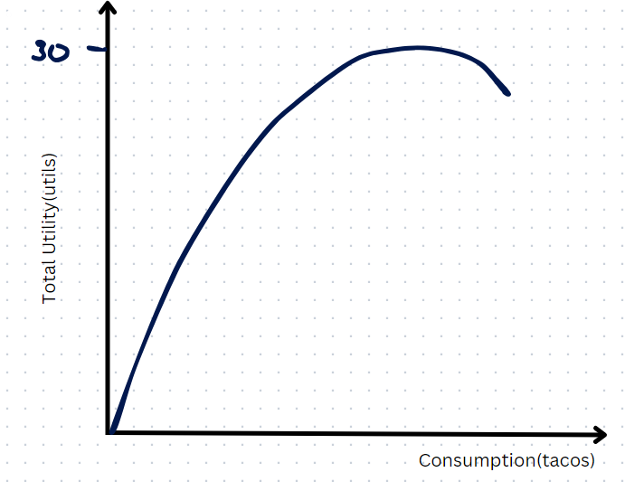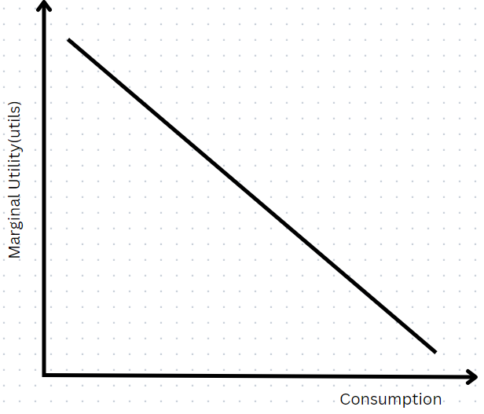

- The MU curve can be translated to the demand curve.
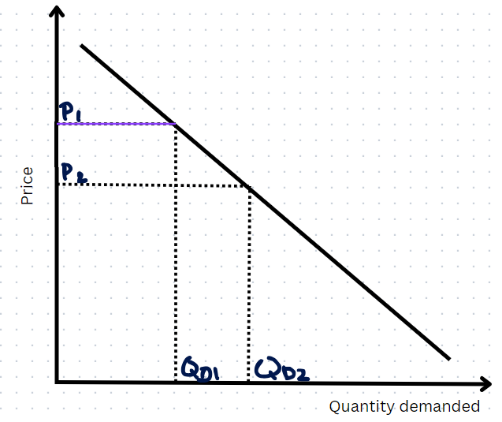
MU ↑ P ↑ TU ↓
When the good is difficult to access

MU ↓ P ↓ TU ↑
When the good is easy to access

Examples:
- Diamond\Water Paradox
- Cash and non-cash gifts

LECTURE FIVE

Demand: The desire backed by the willingness and ability of the individual to purchase goods and services at variable prices.
Quantity Demanded: A specific amount of a good or service that buyers are willing and able to purchase at a particular price.

Willingness: decision making, choice.
Ability: talent/income.
Purchase: making the buying decision.
Variable Prices: many prices of a single product, related product, different product.

Demand Curve:



FACTORS AFFECTING DEMAND
- Price:
Price↑ ↓Quantity Demand (viceversa)
Harder to purchase

- Income:
Income↑ ↑Demand (viceversa)
More money to spend

- Customers:
Customer↑ ↑Demand (viceversa)

- Substitutes: Parallel products with similar features but different brands.

Substitutes↑ ↓Demand (viceversa)
There are similar things to buy

- Complements: These are goods that go together, like toothbrush and toothpaste. So an increase in the demand of one product increases the demand of the other product as well.
Example: If the price of a toothbrush increases, the quantity demanded decreases, leading to a decrease in the quantity demanded of toothpaste.
Example: If fuel prices increase, car demand decreases, and public commute usage increases.
NB: both products can also be bought separately and so are complete products on their own.
- Season: Events and timeframes. Like summer/winter, religious holidays etcetera also affect demand for products.
- Time: With time, certain products become less desirable, like CDs, so their demand diminishes. At other times, the opposite happens. Over time, you make better financial decisions, income brackets change, and preferences evolve.

Quantity Demanded (Qd) | Demand
Depends on price. | Depends on income
It is only a point on the curve. | It is the curve.
Change of Qd is along the curve:  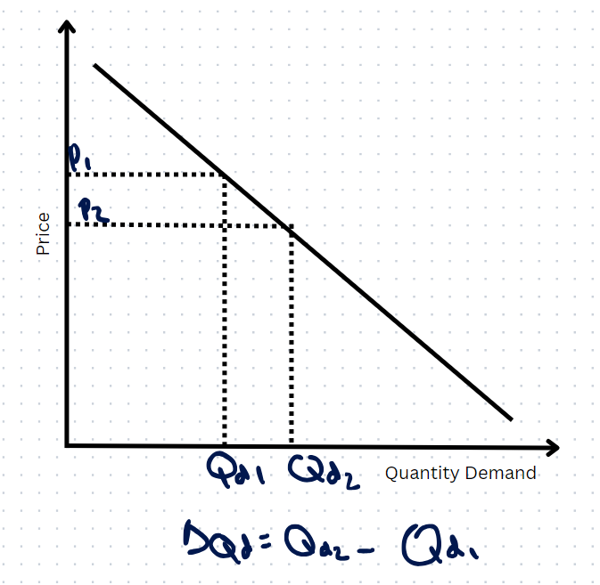 | Change of Demand shifts the curve:  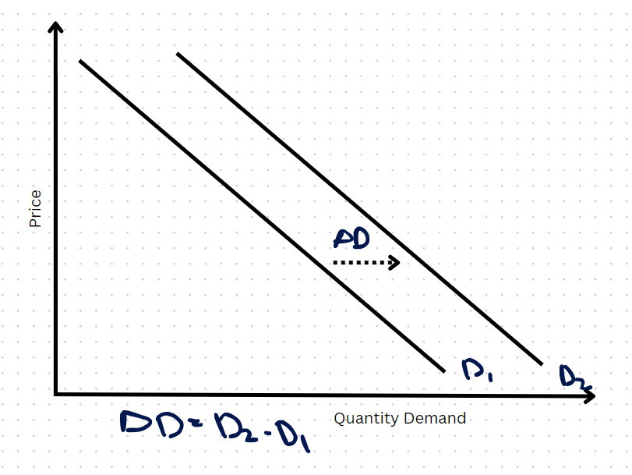

- Demand is the quantity of a good or service that consumers are willing and able to buy at given prices during a period of time. Quantity demanded is the amount of a good or service people will buy at a particular price at a particular time. (source: econedlink)
- Video reference: Demand vs Qd.

Questions

Q1) Assume that the income of an individual increases with the prices of product and services constant. What will be the change on the demand curve?
The curve shifts to the right. (income increases, quantity demanded increases, overall demand increases)

Q2)If the cell phone and sim are complementary to each other, and the price of the sim increases, will the individual purchase new phones or not? Also how will it affect the demand?
The curve shifts to the left. (sim price increases, demand for cell phones decreases)

LECTURE SIX
Supply: It is the desire backed by the willingness and ability of the producer to make goods and services available at variable prices during a given period.
Quantity Supplied: A specific amount of a good or service that sellers are willing and able to offer for sale at a particular price.

A rational producer must incur profits, must maximize profits

P(Price) directly proportional to Qs(Quantity Supply)

Supply Curve:

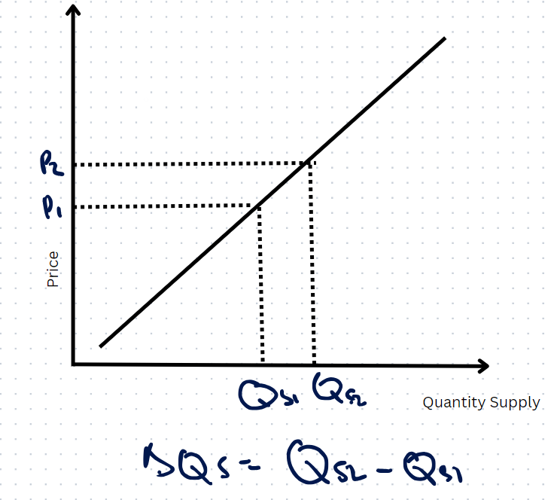

FACTORS AFFECTING SUPPLY
- Price:
Price↑ ↑Quantity Supply (viceversa)

- Cost of Inputs:
Cost of Inputs↑ ↓Supply (viceversa)

- Technology:
Technology↑ ↑Supply (viceversa)

- Tax:
Tax↑ ↓Supply (viceversa)

- Season: Events and timeframes. Like summer/winter, religious holidays etcetera also affect supply for products.

- Time: In time supplies learn to: specialize, expand and diversify.

Qs | Supply
Depends on price | Depends on technology
Change of Qs is along the curve:   | Change of supply shifts the curve  (paradigm shift):  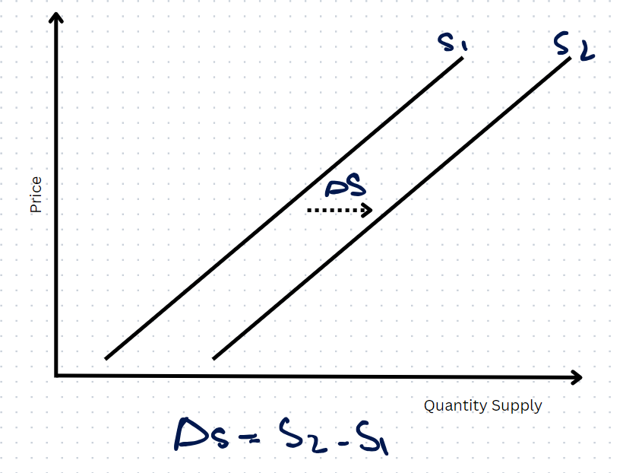

- Quantity Supplied is specifically related to changes in the price of the good. It reflects the amount producers are willing and able to sell at a given price.
- Supply refers to the overall relationship between the price of a good and the total quantity of that good available in the market, influenced by factors like input costs, technology, taxes, seasonal conditions, and time.

DEMAND & SUPPLY TOGETHER

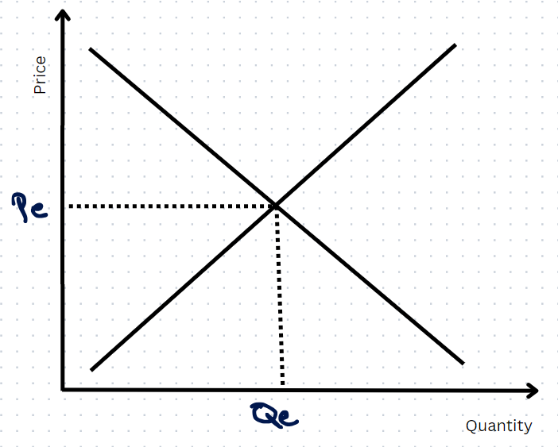

- Pe = Equilibrium Price, Qe = Equilibrium Quantity.
- Balance of demand and supply forces.

CASES:
- Income↑ and Supply constant: Spending increases as income increases.
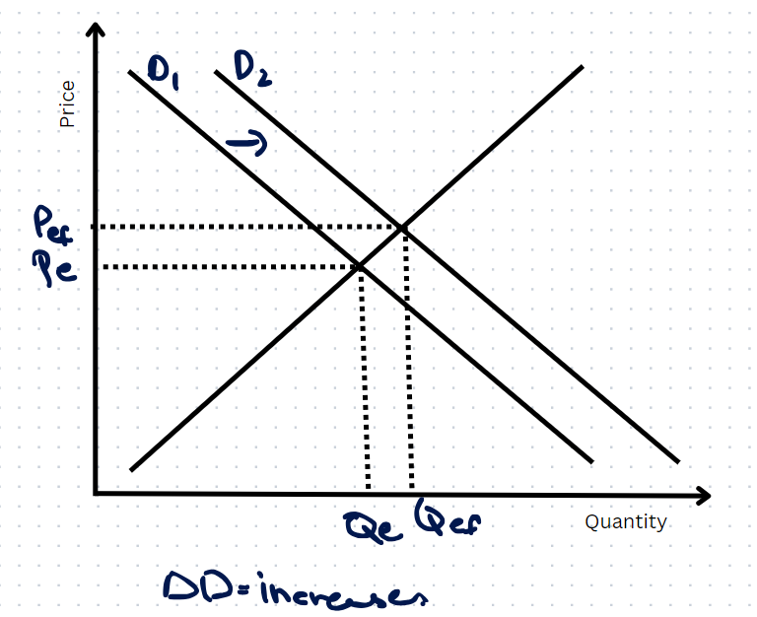

- Taxes↓ and demand is constant:
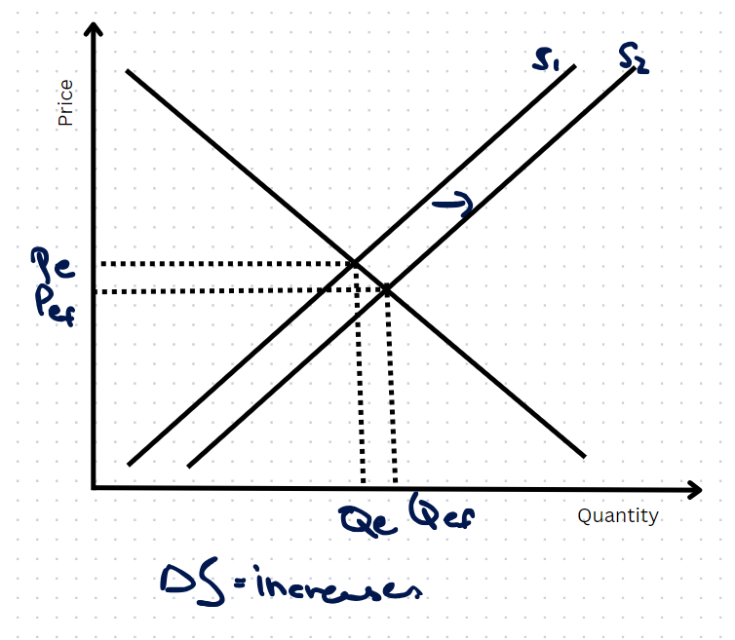

- Technological improvement↑ and Demand not constant:
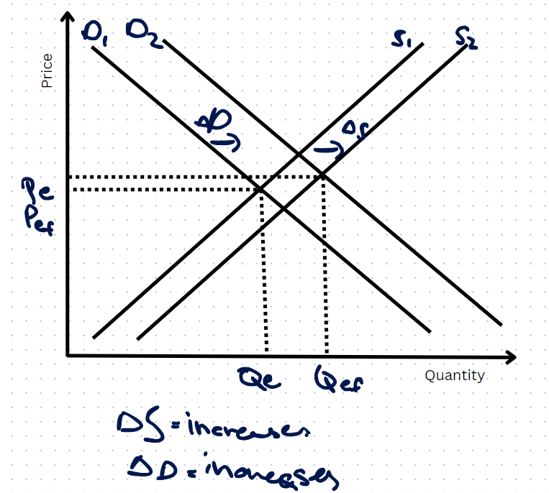

- iPhone/iPad
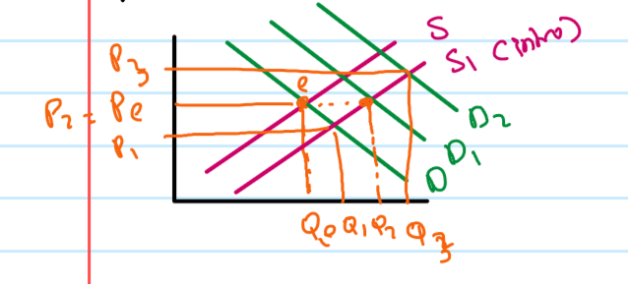

LECTURE SEVEN

Equilibrium: The market condition where supply equals demand, and the market price stabilizes.
- Price Floor: A minimum price set by the government above the market equilibrium, preventing sales below this price, which can lead to surpluses.
- Price Ceiling: A maximum price set by the government below the market equilibrium, preventing sales above this price, which can lead to shortages

Case 1: Wheat Floor (Price Floor):
Government wants to support the wheat farmers and sets a price of wheat wheat above the market price, with a promise to purchase the surplus.

Surplus: When the supply is greater than the demand, the leftover is surplus.

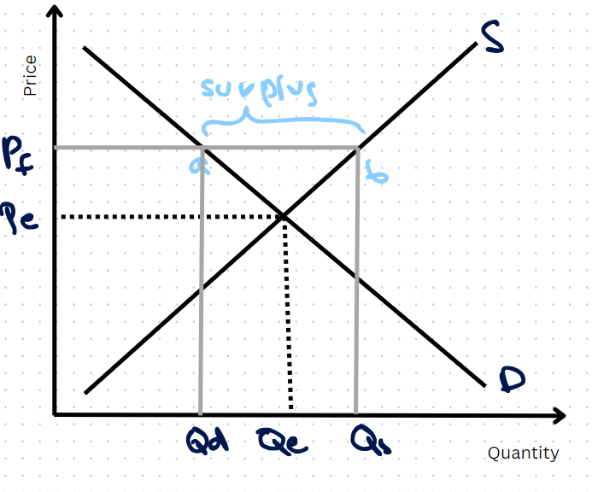

Questions

Q1) Would the farmers be satisfied with the new price?
Yes, since (O - Qe) < (O - Qs), meaning quantity increases.

Q2) Would the customers be satisfied with the new price?
No, since (O - Qe) > (O - Qd)

Q3) What would the government do with the surplus?
- Export
- Store/Reserve
- Give as foreign aid
- Sell at lower price to other areas in the country with less wheat supply

Case 2: Wage Floor (Price Floor)
The government wants to support the working class and sets a minimum wage above the market rate, without any promise to accommodate if workers become unemployed.

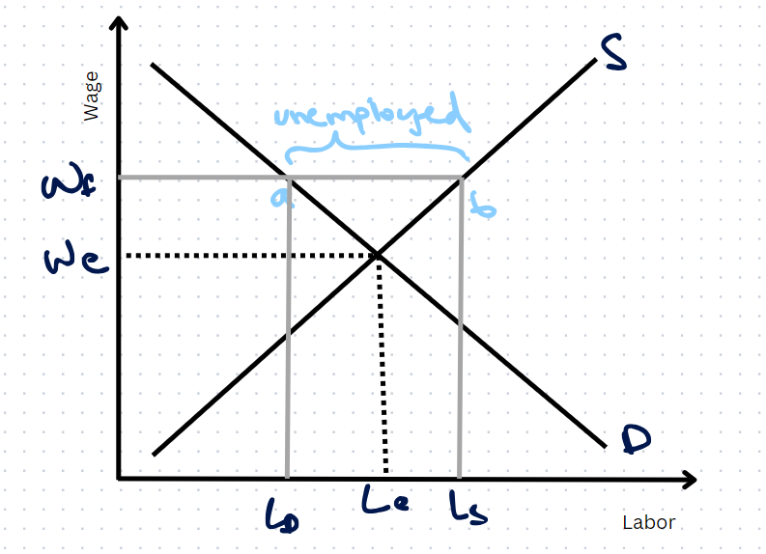

Questions

Q1) Who are the stakeholders?
Employers, working class, government.

Q2) How would the employers respond to the wage floor?
They will not be happy, since (O - Ld) < (O - Le), hence they will decrease the number of employees.

Q3) Would the working class be willing to work on a higher wage?
Yes, since (O - Ls) > (O- Le).

Q4) What would be the overall outcome of the wage floor?
Increased unemployment

Q5) If employees are forced to hire would that have an effect on the prices of goods and services?
If employers are forced to hire the demand curve will shift rightwards and the equilibrium will be at point b. The employers will also increase the price of the goods and services causing
Wage Push Inflation.

Q6) What are the remedies to deal with unemployment?
- Subsidize taxes for industries
- Create apprenticeship programs
- Expand family profession
- Encourage entrepreneurship
- Provide loans for the working class(eg: Benazir income support)
- Foreign jobs
- Remote work

Wage Push Inflation:

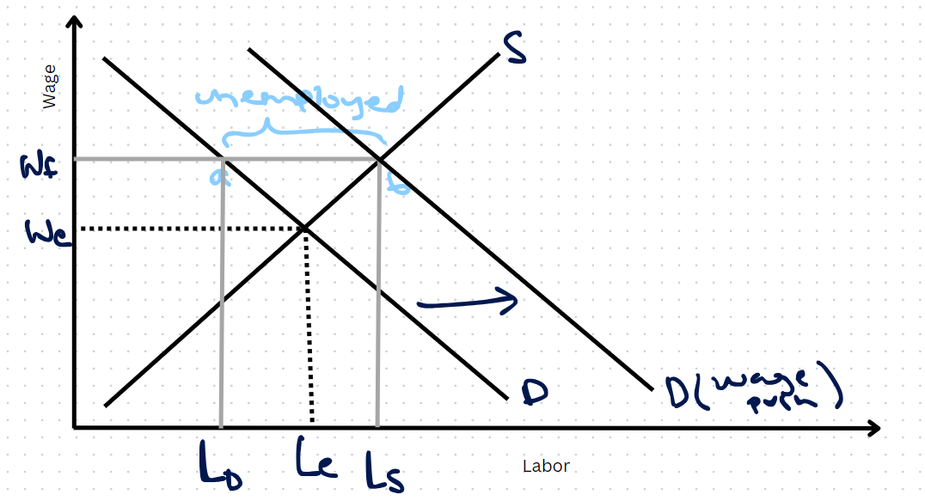

Case 3: Rent Control (Price Ceiling)
The government wants to facilitate the renters by setting a rent below market price with no compensation.

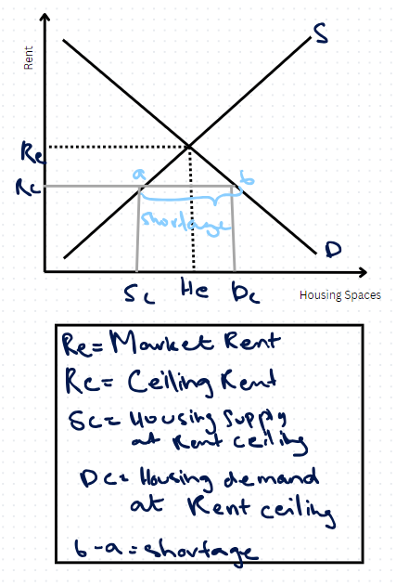

Questions

Q1)Who are the renters?
They pay the rent to the landlords.

Q2)Who are the landlords?
Owner

Q3)Why staying on rent?
- Affordability
- Jobs
- Education
- Mobility

Q4)Would the landlords be happy with the rent ceiling?
No, since (O - Sc) < (O - He), as the price has decreased.

Q5)Renters Response?
Happy, rent more.

Q6)What can be the remedies to this issue(shortage of renting spaces)?
- Living accommodations for the working class, provided by the government and private sectors. Like hostels.
- Government based housing schemes.
- Mortgage.
- Taking remote jobs and staying in your own living space without worrying about commuting.
- Spreading work opportunities beyond the Mega cities.
- Subsidized(by the government) and monitor building of new rental places.
- Opt for simplicity.

Case 5: Lifesaving Drugs (Price Ceiling)
Government imposes a price ceiling(price below market price) on the price of the drugs to facilitate the sick.

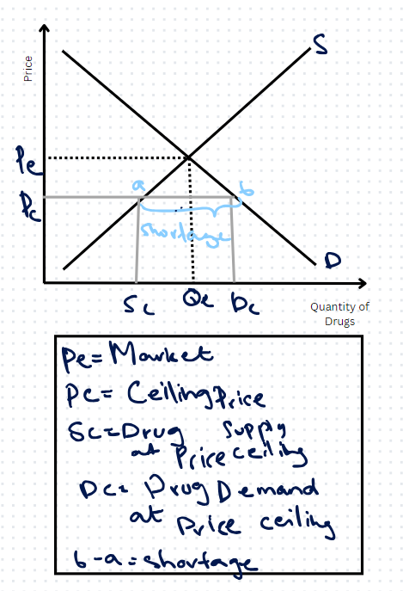

Questions

Q1) Who are the stakeholders?
Pharmaceutical companies, Hospitals.

Q2) What would be the Company’s response?
Not happy, they will decrease the supply of drugs.

Q3) What would be the hospital’s response?
Happy, they will however increase the price of the treatment to keep up with the shortage.

Q3) What would be the remedies for the resulting problems?
- Fund research for cheaper alternatives
- Increase market substitutes
- Sell at lower price/loans to places with lower income index
- Introduce fuel price ceiling

Case 6: Fuel Price (Price Ceiling)
Accommodation for consumers provided by the government by decreasing the fuel price from the market price.
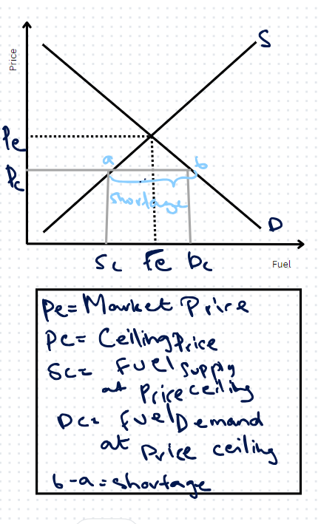

Questions

Q1) Who are the stakeholders?

Q2) What would be the response of the consumers?

Q3) What would be the response of the sellers?

Q4) What will be the effect of the supply?

Q5)What are the remedies?
- Smuggling control
- Find alternative fuel supplies
- Use public transport
- Use fuel cards
- Electric

LECTURE EIGHT
ELASTICITY: Elasticity in economics refers to the measure of responsiveness of one variable to changes in another. Specifically, it shows how much the quantity demanded or supplied of a good or service changes in response to a change in price, income, or other factors.
Types of Elasticity Coefficients (Ed/Ey):


Elasticity of demand: measures how much the quantity demanded changes when the price (or other factors of demand) of a good changes.

Income Elasticity of Demand: measures how demand responds to changes in consumer income.
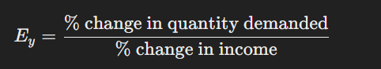

Arc Elasticity of Demand: When the change in price/income and quantity is large, and elasticity is calculated over a range, averaging the values for more accuracy with larger changes.
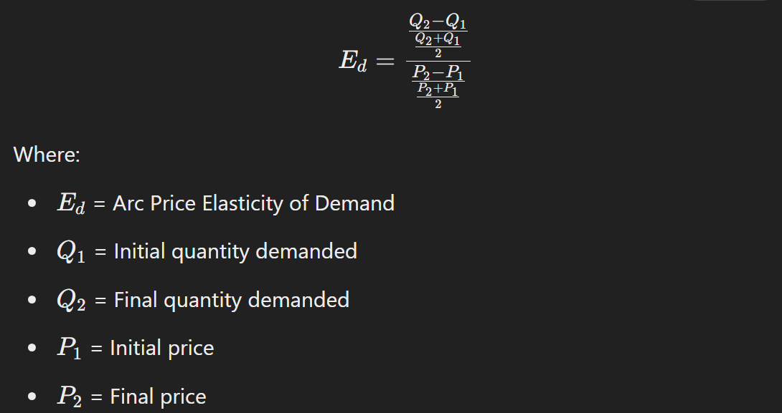

Point Elasticity of Demand: Measures the elasticity at a specific point on the demand curve for a small change in price or income.
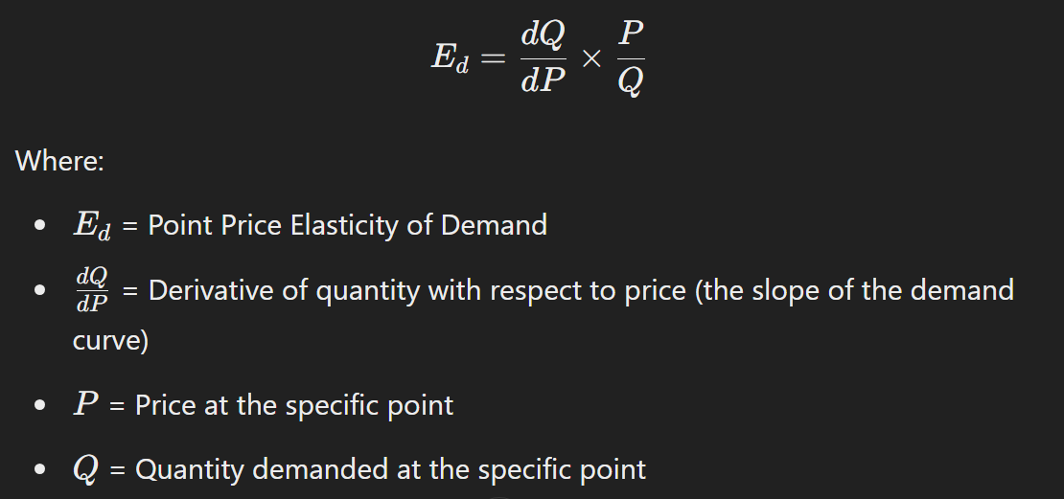
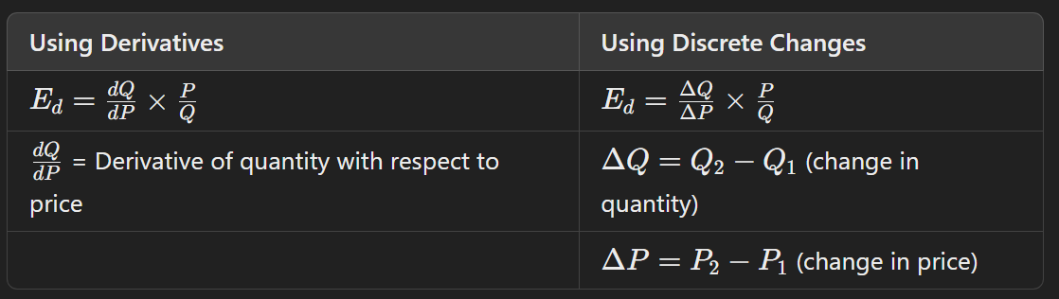

Arc Cross-Price Elasticity of Demand: Measures how the quantity demanded of one good responds to changes in the price of another good.
If Ecross < 0 - complements
If Ecross > 0 - substitutes
If Ecross = 0 - unrelated
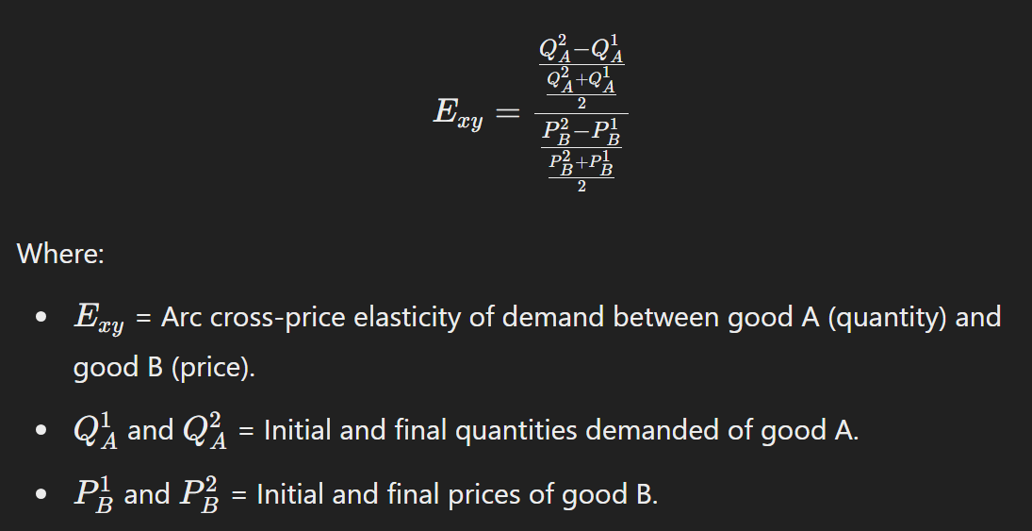
Arc Advertising Elasticity of Demand: Measures how the quantity demanded responds to changes in advertising expenditure.

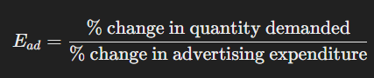

Elasticity Condition | Value of Ed | Description
Perfectly Inelastic | Ed=0 | Quantity demanded does not change with price changes.
Relatively Inelastic | 0<Ed<1 | Quantity demanded changes less than proportionately to price changes.
Unitary Elastic | Ed=1 | Quantity demanded changes proportionately to price changes.
Relatively Elastic | Ed>1 | Quantity demanded changes more than proportionately to price changes.
Perfectly Elastic | Ed=∞ | Quantity demanded changes infinitely with any price change.

TYPES OF ELASTICITY:
Perfectly Inelastic:
Examples: cancer treatment, chemotherapy sessions, radiotherapy sessions
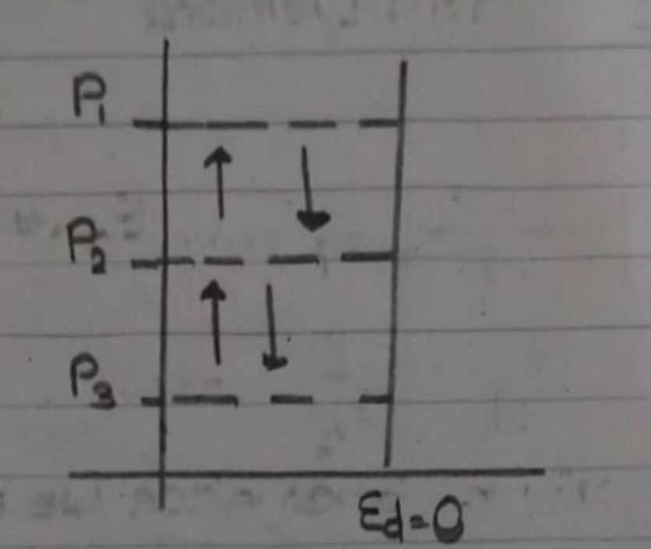
Relatively Inelastic:
Examples: Necessities (medicine, apparels, food)
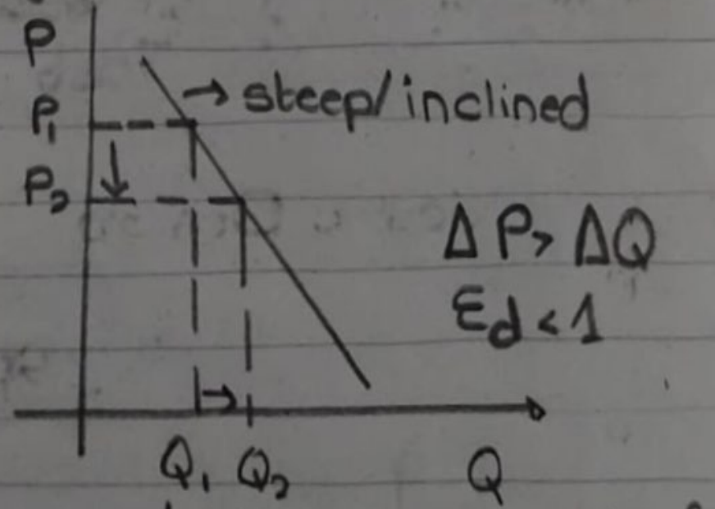
Perfectly Elastic:
Examples: Salt, price doesn't fluctuate, quantity increases indefinitely. In case of Pakistan, since we are producers, salt comes under perfectly elastic. If we would impor tit then it would be relaitvely inelastic,. If we see it in terms of price with no competition then price shall be constant. Same for oil for gulf, middle East
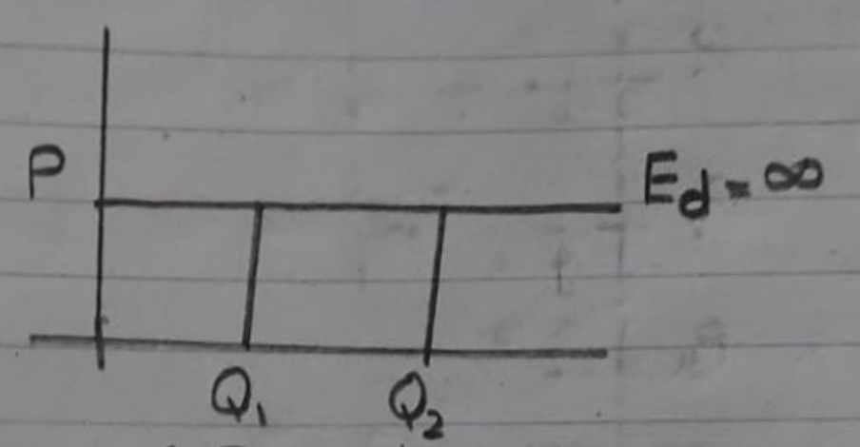
Relatively Elastic:
Examples: Luxuries, alternatives, pencils.
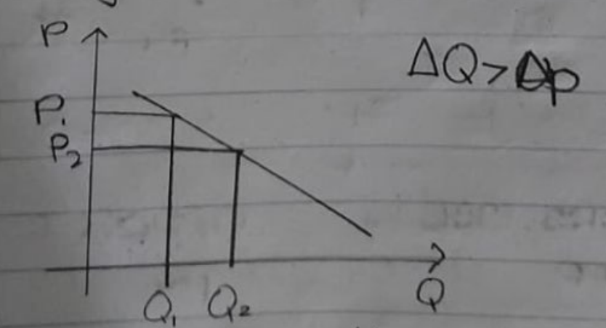
Unitary Elasticity: when the percentage change in quantity demanded equals the percentage change in price, resulting in an elasticity coefficient of 1.

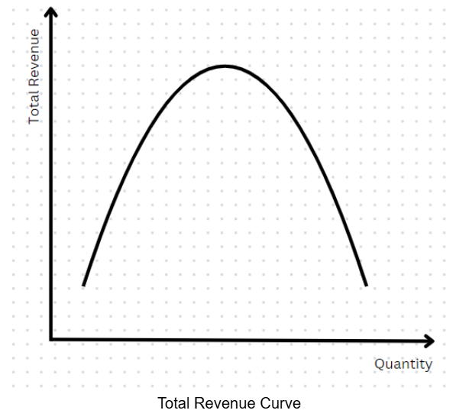
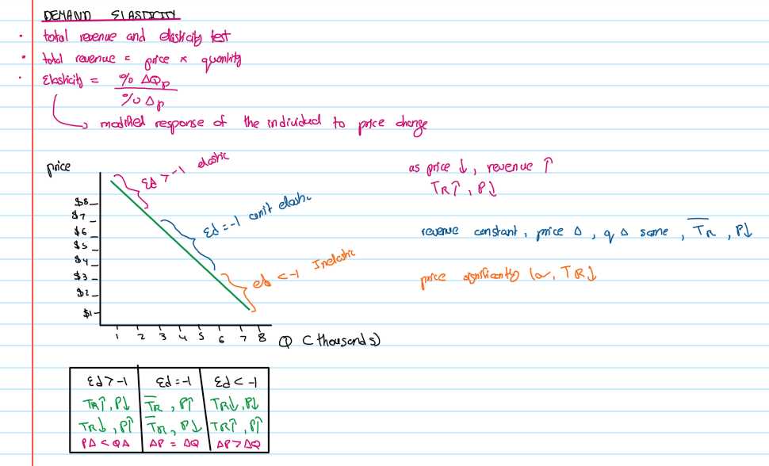
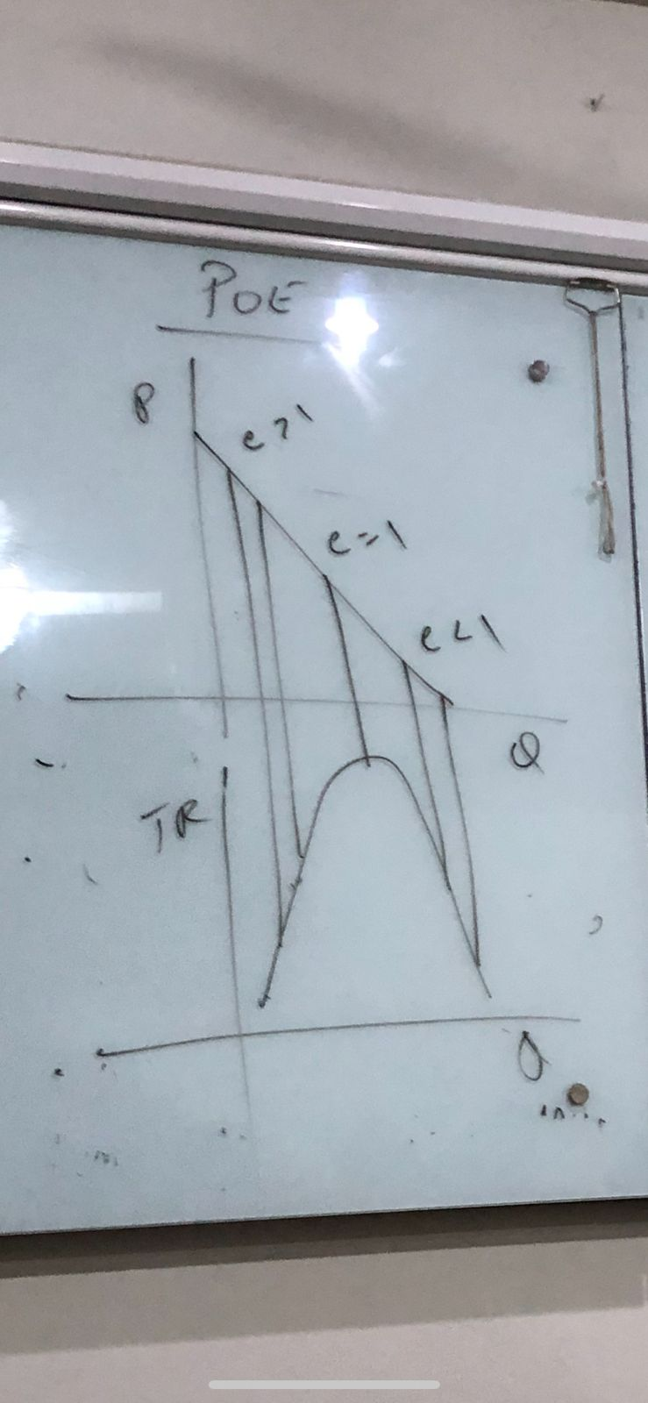

LECTURE NINE
Utility Maximization Rule: In order to maximise utility, the consumer should allocate his/her money/income in a manner that the last dollar spent on each good yields equal utility per dollar

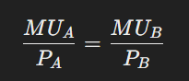
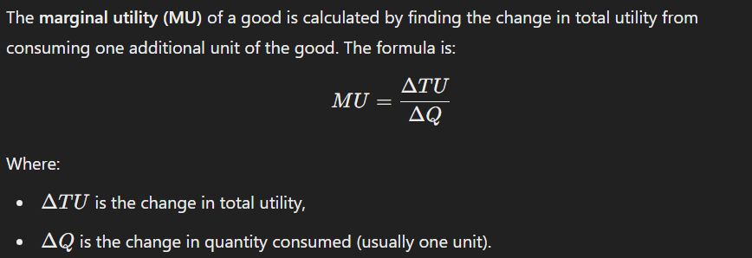


ASSUMPTIONS OF CONSUMER BEHAVIOUR:
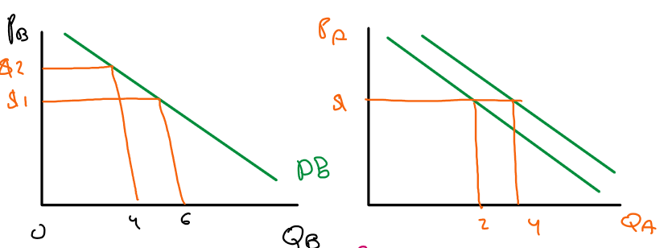
- Rationality followed
- Prices unchanged
- Preferences ignored
- Budget Constraints constant

EXAMPLE QUESTIONS
- P(A) = $1, P(B) = $2, M (Income) = $10

Unit of Product A | MU(A) | MU(A) / P(A) | Unit of Product B | MU(B) | MU(B) / P(B)
1 | 10 | 10 | 1 | 24 | 12
2 | 8 | 8 | 2 | 20 | 10
3 | 7 | 7 | 3 | 18 | 9
4 | 6 | 6 | 4 | 16 | 8
5 | 5 | 5 | 5 | 12 | 6
6 | 4 | 4 | 6 | 6 | 3
7 | 3 | 3 | 7 | 4 | 2

Utility will be maximized if the consumer uses 2 goods of A ($2) and 4 goods of B ($8). Total = $10. If P(B) changed to $ 1 then 4 goods of A and 6 goods of B.

- M = $106, P(A) = $18, P(B) = $6, P(C) = $4

Unit of Product A | MU(A) | MU(A) / P(A) | Unit of Product B | MU(B) | MU(B) / P(B) | Unit of Product C | MU(C) | MU(C) / P(C) | Savings
1 | 72 | 4.00 | 1 | 24 | 4.00 | 1 | 15 | 3.75 | 1
2 | 54 | 3.00 | 2 | 15 | 2.50 | 2 | 12 | 3.00 | 2
3 | 45 | 2.50 | 3 | 12 | 2.00 | 3 | 8 | 2.00 | 3
4 | 36 | 2.00 | 4 | 9 | 1.50 | 4 | 7 | 1.75 | 4
5 | 27 | 1.50 | 5 | 7 | 1.17 | 5 | 5 | 1.25 | 5
6 | 18 | 1.00 | 6 | 5 | 0.83 | 6 | 4 | 1.00 | 6
7 | 15 | 0.83 | 7 | 2 | 0.33 | 7 | 3.5 | 0.88 | 7

Utility will be maximized if the consumer uses 4 goods of A ($72), 3 goods of B ($18), and 3 goods of C ($12), while saving $4. Total = $102

If there is no situation where MUa/Pa=MUb/Pb then answer: no allocation for this case (money is saved),

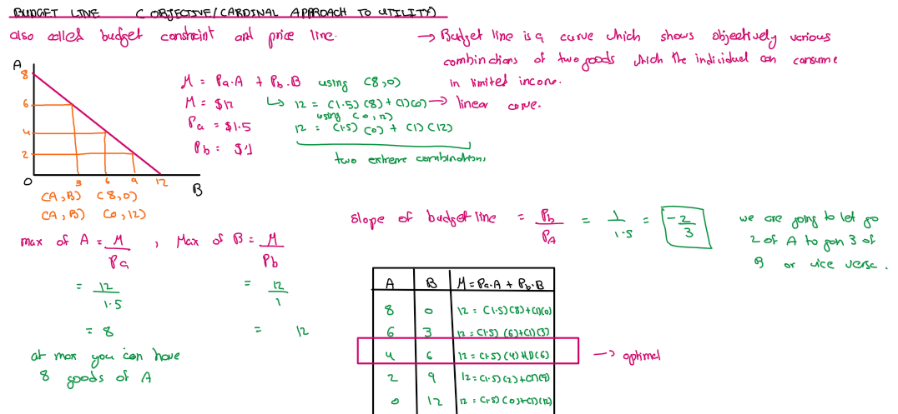
BUDGET LINE: A budget line is a curve that represents all possible combinations of two goods that a consumer can purchase, given their limited income and the prices of the goods. It shows the trade-off between the two goods based on the consumer's budget constraint.
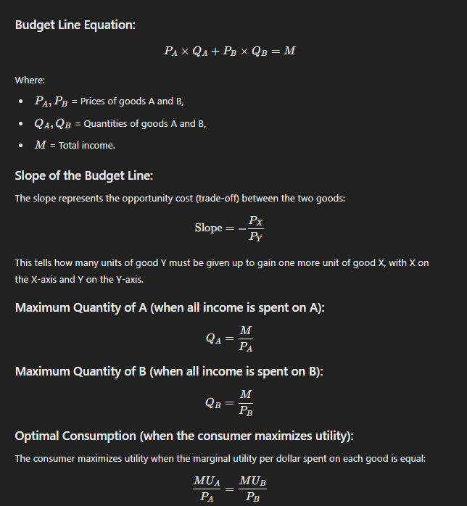

PROPERTIES:
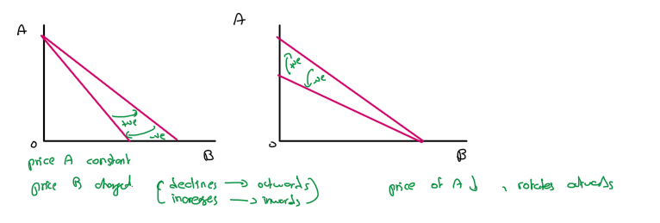
- Can rotate on either axes (price causes rotation): A change in the price of one good causes the budget line to rotate around the intercept of the other good.
Keep in mind the graph maps quantities of goods A & B, hence when price varies, quantity varies inversely
- Can partially shift: A change in income results in a parallel shift of the budget line, moving outward with an increase in income and inward with a decrease.

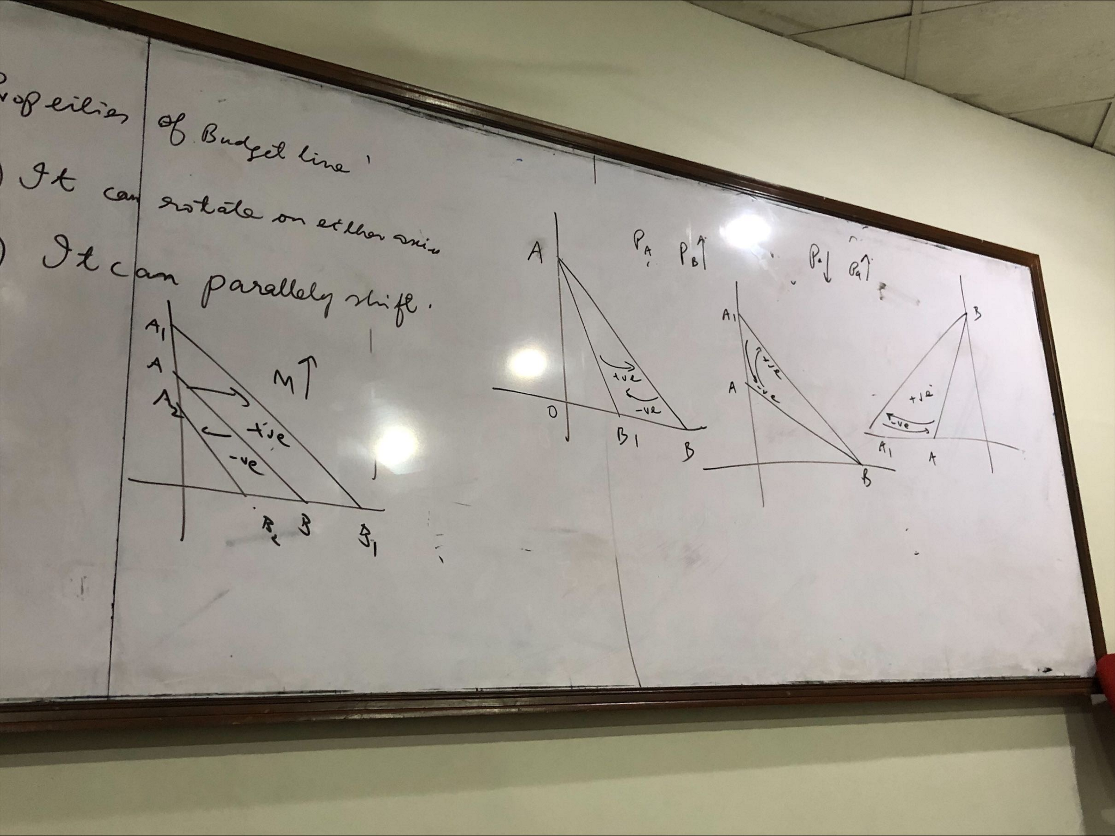

INDIFFERENCE CURVE: An indifference curve is the locus of points that represents all the combinations of two goods that provide the same level of utility or satisfaction to a consumer. Each point on the curve indicates a different combination of the two goods that the consumer views as equally desirable.

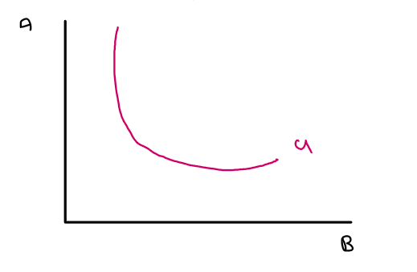

PROPERTIES:
- Convex to origin: satisfies the law of diminishing marginal utility, where as more units of a good are consumed, the additional satisfaction (marginal utility) decreases. They also satisfy the marginal rate of substitution (MRS), which states that as one good is substituted for another, increasing amounts of the sacrificed good are needed to maintain the same utility level. MRS can be determined using the slope (gradient) of the indifference curve.
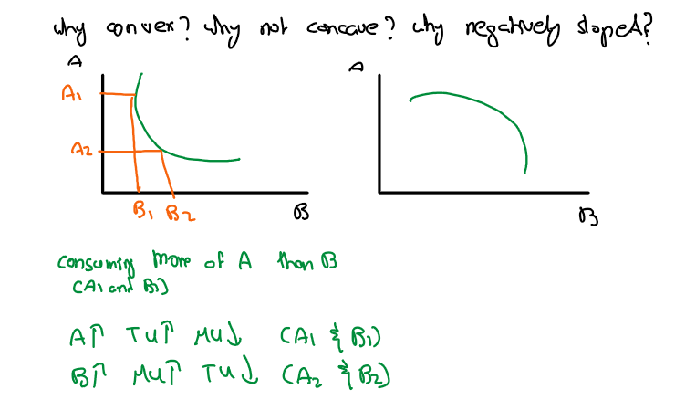
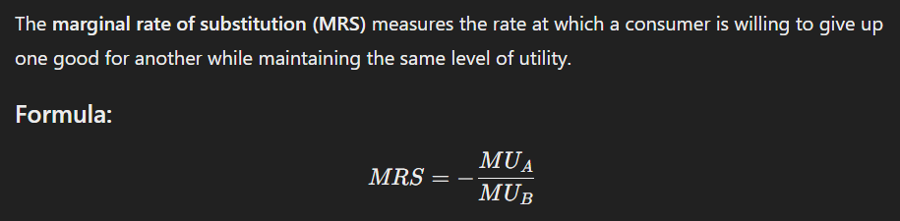
- Indifference Map: multiple indifference curves representing various utility levels, helping consumers visualize their preferences between combinations of goods.
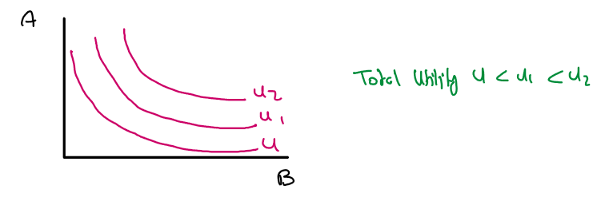
Total Utility along the indifference curve remains the same
The further you move away from the origin, the higher the total utility
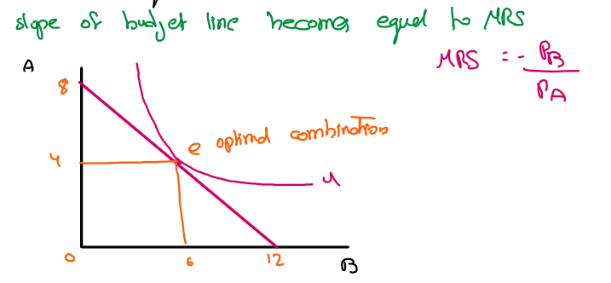
- Consumer Equilibrium: when a consumer maximizes utility at the point where the highest indifference curve is tangent to the budget line, indicating an optimal good combination within their budget.

Normal Goods: Demand increases as income rises, following the law of demand where price and quantity demanded are inversely related.
Giffen Goods: Demand increases as price rises, defying the law of demand due to their status as inferior goods with limited substitutes.

Characteristic | Normal Goods | Giffen Goods
Definition | Demand increases with income; follows the law of demand (price decreases → quantity demanded increases). | Demand increases with price; defies the law of demand (price increases → quantity demanded increases).
Examples | Organic food, electronics, clothing. | Staple foods like bread or rice during a famine.
Consumer Behavior | More purchased with higher income or lower prices. | More purchased despite higher prices due to necessity.
Pricing Strategy | Uses psychological, competitor pricing, and cost-plus pricing strategies. | Less common pricing strategies; reflects necessity.

NOTE: Luxury goods are not Giffen goods, even if they sometimes violate the law of demand because they are associated with high quality and status. They utilize premium pricing strategies.

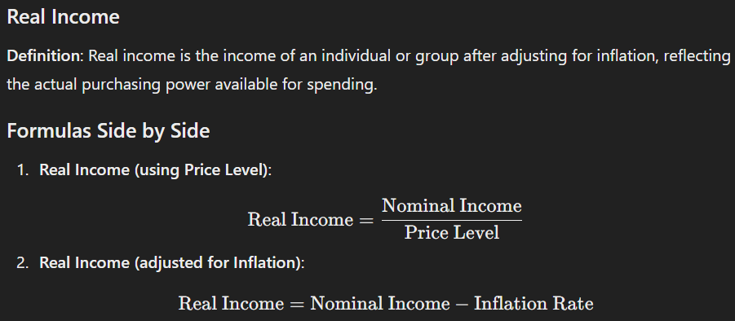

Pricing Strategy | Description | Example
Competitor Pricing | Setting prices based on competitors' prices to remain competitive. | Pricing similar to rival brands.
Psychological Pricing | Setting prices to create a perception of value, such as pricing something at $9.99 instead of $10. | Pricing a product at $19.99 instead of $20.
Cost-Plus Pricing | Calculating the total cost of production and adding a markup for profit. | Manufacturing costs + 20% markup.
Premium Pricing | Setting a high price to reflect exclusivity and quality, often associated with luxury brands. | High-end fashion brands charging premium prices.
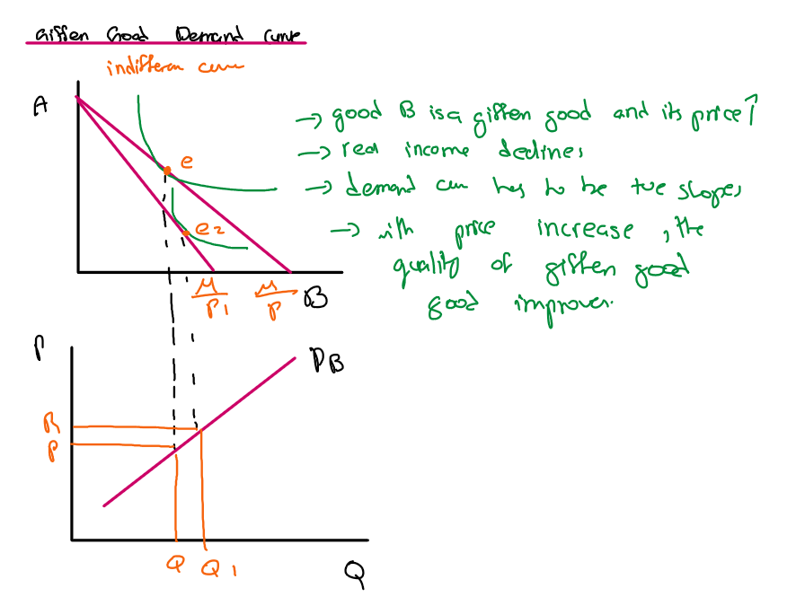
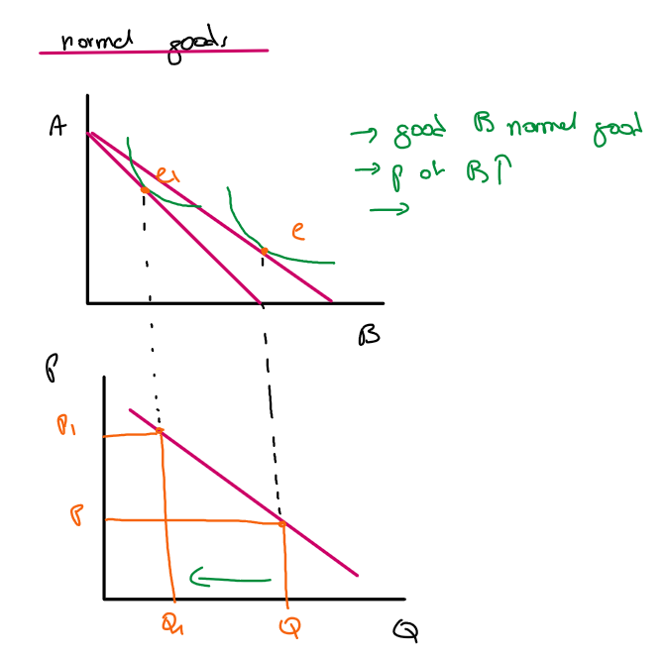

NORMAL FOODS GIFFEN GOODS
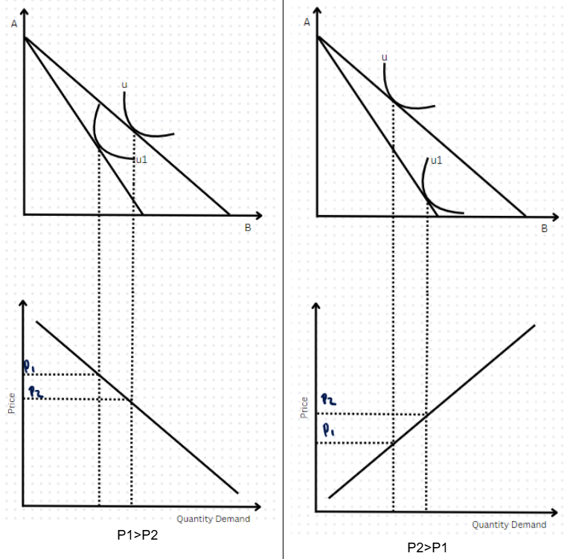

LECTURE TEN
COST OF PRODUCTION
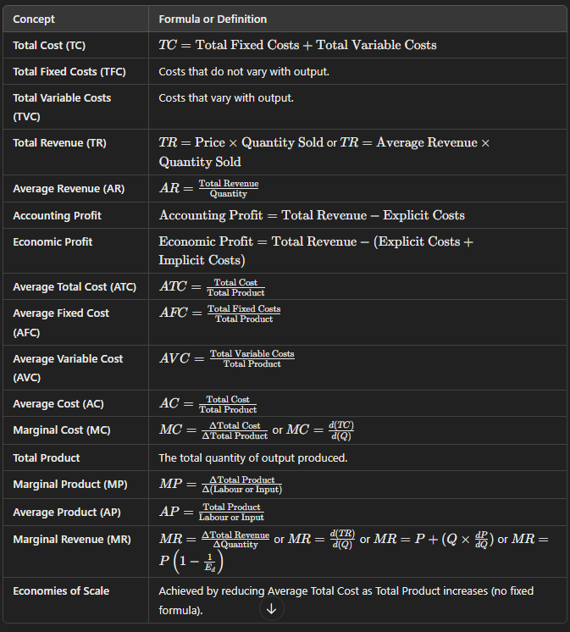
Cost: Charge/Total expenditure incurred in producing goods/services.
Fixed Costs: Costs that do not change with the level of output. Examples: Rent, salaries, equipment, infrastructure, house.
Variable Costs: Costs that vary with the level of output. Example: Raw materials, utilities, fuel costs.
Explicit Cost: Direct, out-of-pocket payments (e.g., wages, rent). Examples: Salaries paid to employees, utility bills, fuel charges, tuition fees, etc.
Implicit Cost: Opportunity costs of using owned resources (no direct payment, hidden, not quantified by accountants). Example: Forgone salary if the owner works in their own business.
Accounting Profit: Profit calculated using only explicit costs. (Accounting Profit is always greater than Economic Profit)
Economic Profit: Profit considering both explicit and implicit costs.
Sunk Cost: A sunk cost is an expense that has already been incurred and cannot be recovered, such as a non-refundable movie ticket you bought for $15 or $100,000 spent on failed product development.
Law of Diminishing Returns: As successive units of variable resources are added, the total product may increase to a certain point but the marginal product will decline. In the short run, adding more of one input (while keeping others fixed) eventually yields lower per-unit returns.

ASSUMPTIONS
- Short Run
- Labor is variable
- Technology is fixed
Units of variable resources | Total Product | Marginal Product | Average Product
0 | 0 | 0 | 0
1 | 10 | 10 | 10
2 | 25 | 15 | 12.5
3 | 45 | 20 | 15
4 | 60 | 15 | 15
5 | 70 | 10 | 14
6 | 75 | 5 | 12.5
7 | 75 | 0 | 10.75
8 | 70 | -5 | 3.75
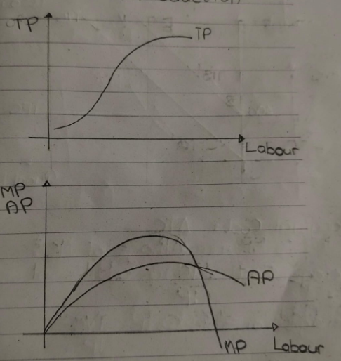
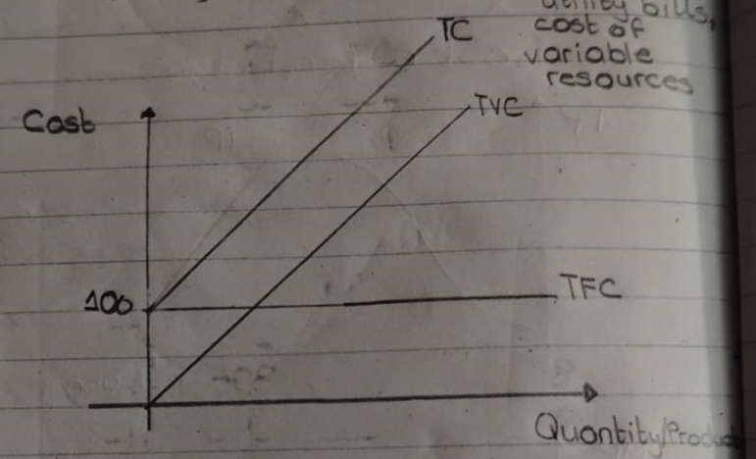

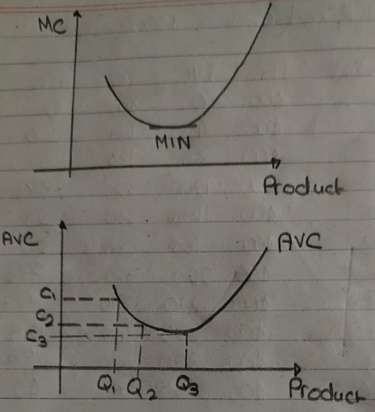
Why is the marginal cost curve a mirror image of the marginal product curve?
Marginal Cost is the cost of producing additional output whereas marginal product is the additional output. They are mirror images because of the law of diminishing returns

Why the AVC Curve is U-Shaped in Terms of Cost per Unit
Economic Reason: The AVC curve is U-shaped because, at first, the cost per unit decreases as production increases due to specialization and improved efficiency. However, as the firm reaches maturity and engages in mass production, the cost per unit begins to rise due to diminishing returns.

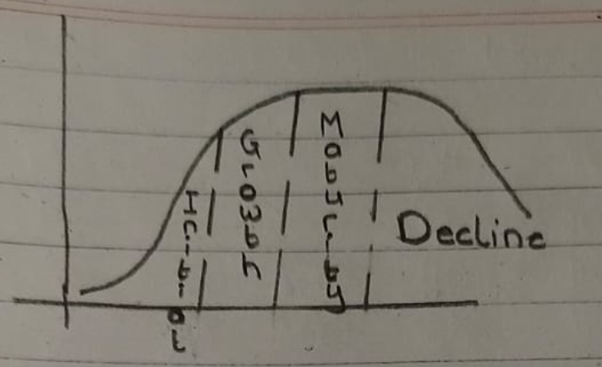
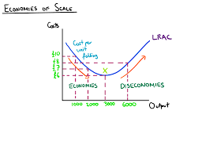
Mathematical Reason: Initially, the AVC curve shows a steep decline in cost per unit as output increases, indicating high efficiencies. The slope flattens out, reflecting lower average costs per unit. Eventually, the slope rises again as diminishing marginal returns occur, leading to higher costs per unit during mass production.
PRODUCT CYCLE

Why is there a decline?
- Competition
- Debt
- Less government support

Economies of Scale: Lowering average costs by increasing production in the long run.. Cost advantages gained by expanding the scale of production, leading to lower average costs per unit as output rises.
Economies of Scope: Cost efficiencies realized by producing various products together rather than separately, resulting in lower costs when multiple goods are produced jointly.
Diseconomies of Scale: The increase in per-unit costs that occurs when a company or organization grows too large, leading to inefficiencies and higher average costs as production expands.
LECTURE ELEVEN
PURE COMPETITION: Pure competition is a market structure where a large number of firms sell standardized products, with no single firm able to influence the market price. Key characteristics include:

- Many buyers and sellers: A large number of participants ensures no one can control market outcomes.
- Standardized homogenous product: All firms offer identical products, so consumers are indifferent about which firm they buy from, as long as the price is the same.
- Price takers: Firms cannot control the market price; they must accept the price determined by overall market demand and supply. The price is uniform.
- Free entry and exit: New firms can enter or exit the market with ease, based on economic profitability
- Demand curve: Perfectly elastic
- There is no government

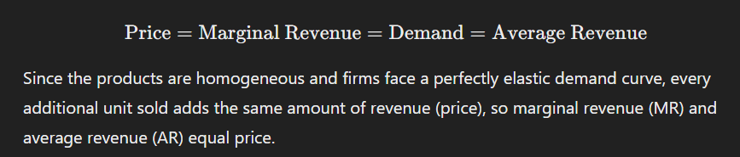

APPLICATIONS:
- Agricultural Markets: Products like wheat, corn, and soybeans. Large number of producers; no single farmer can influence prices; easy entry/exit.
- Commodity Markets: Metals (gold, silver) and raw materials (oil). Standardized goods; prices driven by global supply and demand.
- Stock Markets: Market for shares with many buyers and sellers. No single entity can control prices.
- Generic Drugs: Markets for generic versions of drugs post-patent expiration; many companies produce identical products.
- Call Rates / SMS Packages: Telecom markets where multiple providers offer similar calling and messaging services. Prices are often standardized; consumers choose based on price and service quality, ensuring no single provider can dominate pricing.

PROFIT MAXIMIZATION APPROACHES IN THE SHORT RUN (PURE COMPETITION)

Condition | TR Comparison | Economic Outcome
Economic Profit | TR > TC | Firm is making a profit.
Loss | TR < TC | Firm is incurring a loss.
Break-Even / Normal Profit | TR = TC | Firm is breaking even.
Shutdown Point | TR < AVC | Firm should shut down in the short run.
Indifferent Point | TR = AVC | Firm is indifferent; it covers variable costs but not fixed costs.
*Normal profit is the minimum profit required to cover all costs, including opportunity costs, where total revenue equals total cost. In the long run, all firms exhibit normal profit.

Total Revenue & Total Cost Approach Marginal Revenue & Marginal Cost Approach
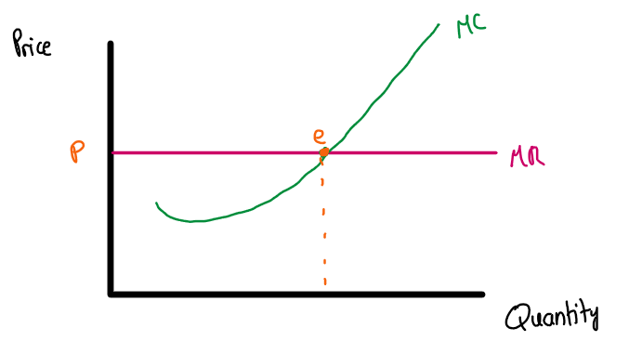
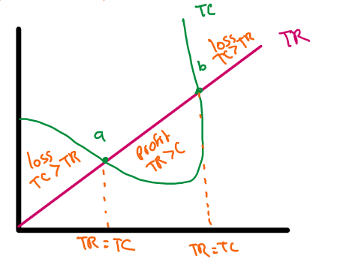
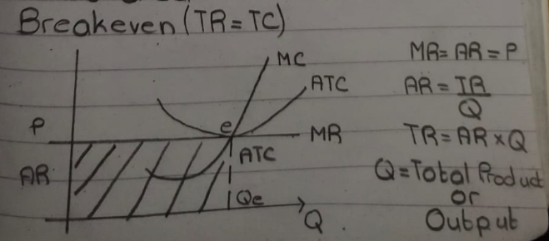
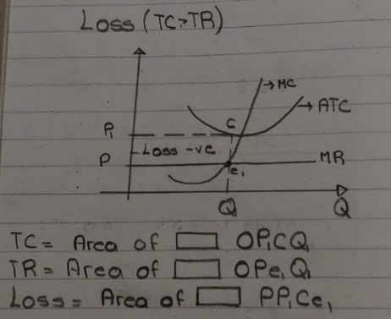
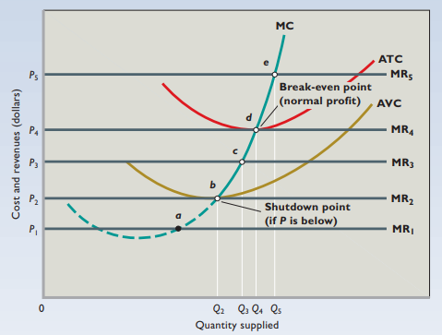
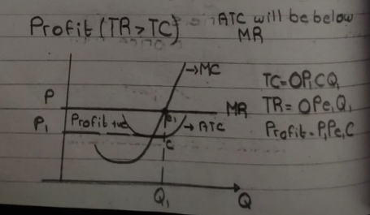

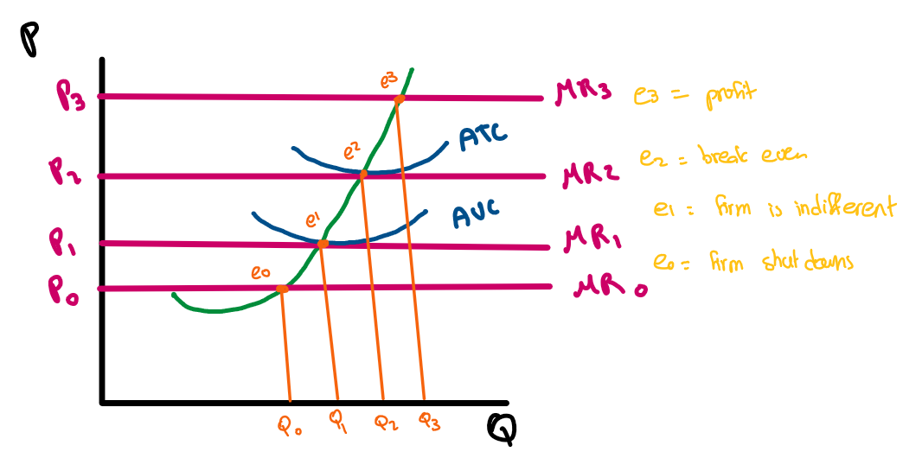

PURE MONOPOLY: Pure monopoly is a market structure where a single firm dominates the entire market, offering a unique product or service with no close substitutes. This firm has significant control over the market price. Key characteristics include:
- Single Seller: There is only one firm supplying the entire market, which enables it to influence prices significantly.
- Unique Product: The product offered by the monopolist is distinct with no close substitutes, making consumers reliant on that single firm.
- Price Maker: The monopolist can set the price for its product, as it controls the market supply. It can adjust output levels to influence market price. Can practise price discrimination - charging different prices for the same product based on customer characteristics or willingness to pay.
- High Barriers to Entry: Significant obstacles prevent other firms from entering the market, such as high startup costs, legal restrictions, or control over essential resources.
- Imperfect Information: Buyers may not have complete knowledge about the product or market conditions, which can limit competition.
- Demand Curve: The demand curve faced by the monopolist is downward sloping, indicating that it can set higher prices by reducing the quantity supplied.
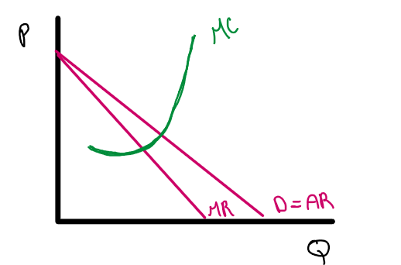
- Issues: Legal and copyright issues

PROFIT MAXIMIZATION APPROACHES IN THE SHORT RUN (PURE MONOPOLY)

Condition | TR Comparison | Economic Outcome
Economic Profit | TR > TC | Firm is making a profit.
Loss | TR < TC | Firm is incurring a loss.
Break-Even / Normal Profit | TR = TC | Firm is breaking even.
Shutdown Point | TR < AVC | Firm should shut down in the short run.
Indifferent Point | TR = AVC | Firm is indifferent; it covers variable costs but not fixed costs.
*Normal profit is the minimum profit required to cover all costs, including opportunity costs, where total revenue equals total cost. In the long run, all firms exhibit normal profit.
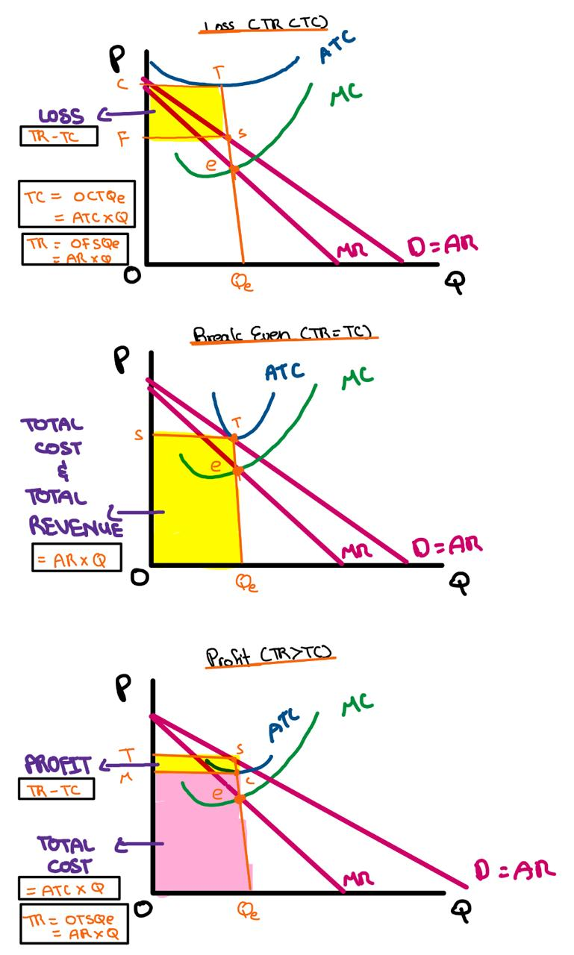

LECTURE TWELVE
MACROECONOMICS: Studies the economy as a whole, covering aggregate measures like GDP, inflation, unemployment, and monetary policy.

NATIONAL INCOME ACCOUNT: Tracks a nation's economic activity by measuring income earned by residents and the total output produced within the country.

Gross Domestic Product (GDP) Total production of goods and services within a country’s borders in a specific time period.
- Normal GDP: Production in the current year × prices of the current year (current dollar GDP)
- Real GDP: Production in the current year × prices of a base year (constant dollar GDP)

Relationship:
Production = Income = Expenditure
(These three components should ideally balance to provide an accurate GDP figure)

Methods to Calculate GDP:
- Product Method: Value added = Final Output − Input. Total goods/services produced at market values in a fixed period.
- Income Method: calculates GDP by summing all incomes earned in a period, including profits (TR - TC), wages (hourly), salaries (monthly), proprietor’s income (self-employed), taxes (government), dividends (stocks/shares), and interest (bonds/securities).
- Expenditure Method: Focuses on the final users of goods/services in the economy.

Autonomous Consumption: The minimum level of consumption that occurs even if income is zero (e.g., spending on necessities like food or rent).
Marginal Propensity to Consume (MPC): The fraction of additional income spent on consumption, showing how much spending increases with extra earnings (e.g., if MPC = 0.8, 80% of new income is spent).
Disposable Income: The income remaining after taxes and mandatory deductions, available for spending or saving.
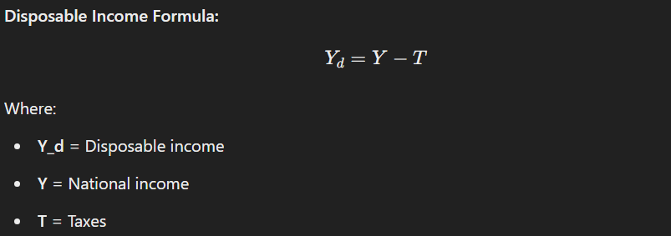
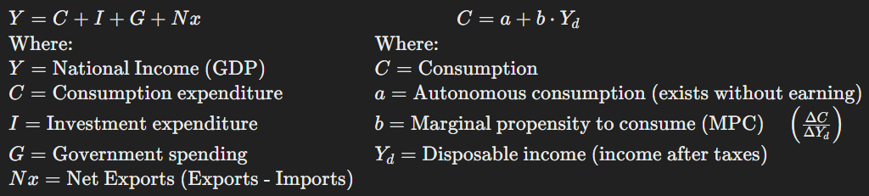

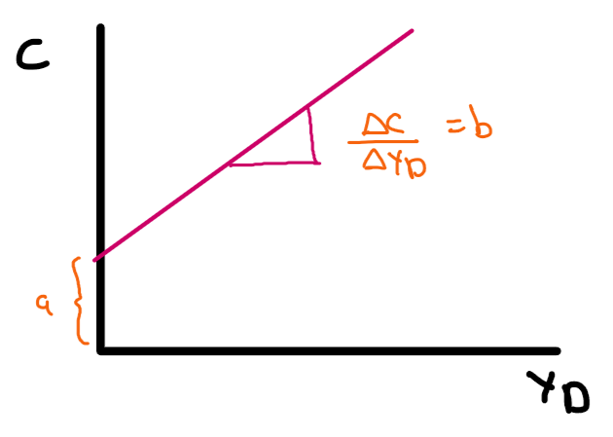
Category | Description | Examples
Consumer Durables | Goods that are used over a long period and do not wear out quickly. | Cars, refrigerators, washing machines, furniture, electronics (TVs, computers)
Consumer Non-Durables | Goods that are consumed or used up quickly and need to be replaced often. | Food, beverages, toiletries, cleaning products, paper goods, clothing

Investment Types
Type | Description | Examples
Residential | Investment in housing or real estate. | Buying a house, renting property, construction of homes
Stocks and Bonds | Investment in financial securities. | Purchasing shares, bonds, mutual funds
Insurance | Investment in policies that provide risk coverage. | Health insurance, life insurance, car insurance

Government Spending Types
Type | Description | Examples
Bailouts/Stimulus Packages | Government financial support to failing sectors or to stimulate the economy. | Financial aid to banks, economic recovery packages
Public Investment | Government spending on infrastructure or public services. | Building roads, bridges, schools, public transportation
Transfers | Government payments made to individuals or entities. | Social Security payments, pensions, unemployment benefits, public hospitals

EXAMPLE:

Orange Inc. | Juice Inc.
Wages paid to employees: $15,000 | Wages paid to employees: $10,000
Taxes paid to government: $5,000 | Taxes paid to government: $2,000
Revenue from sale of oranges: $35,000 | Oranges purchased: $25,000
Oranges sold to the public: $10,000 | Orange juice sales: $40,000
Oranges sold to Juice Inc.: $25,000

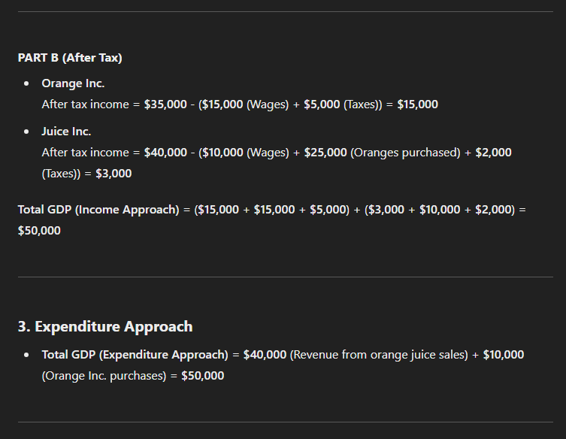

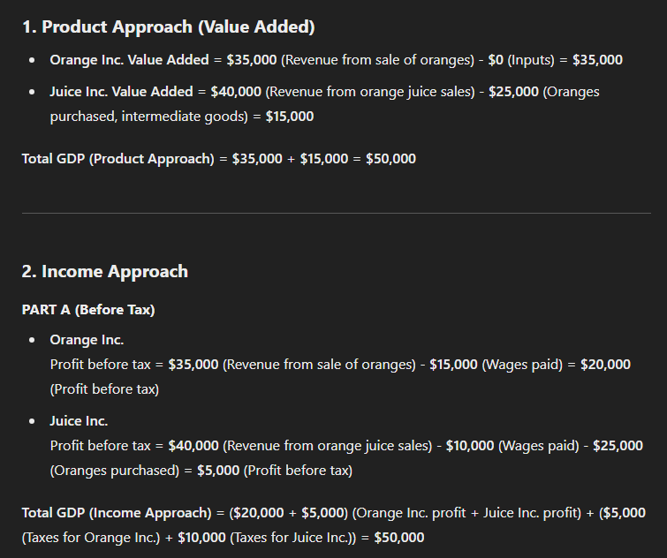
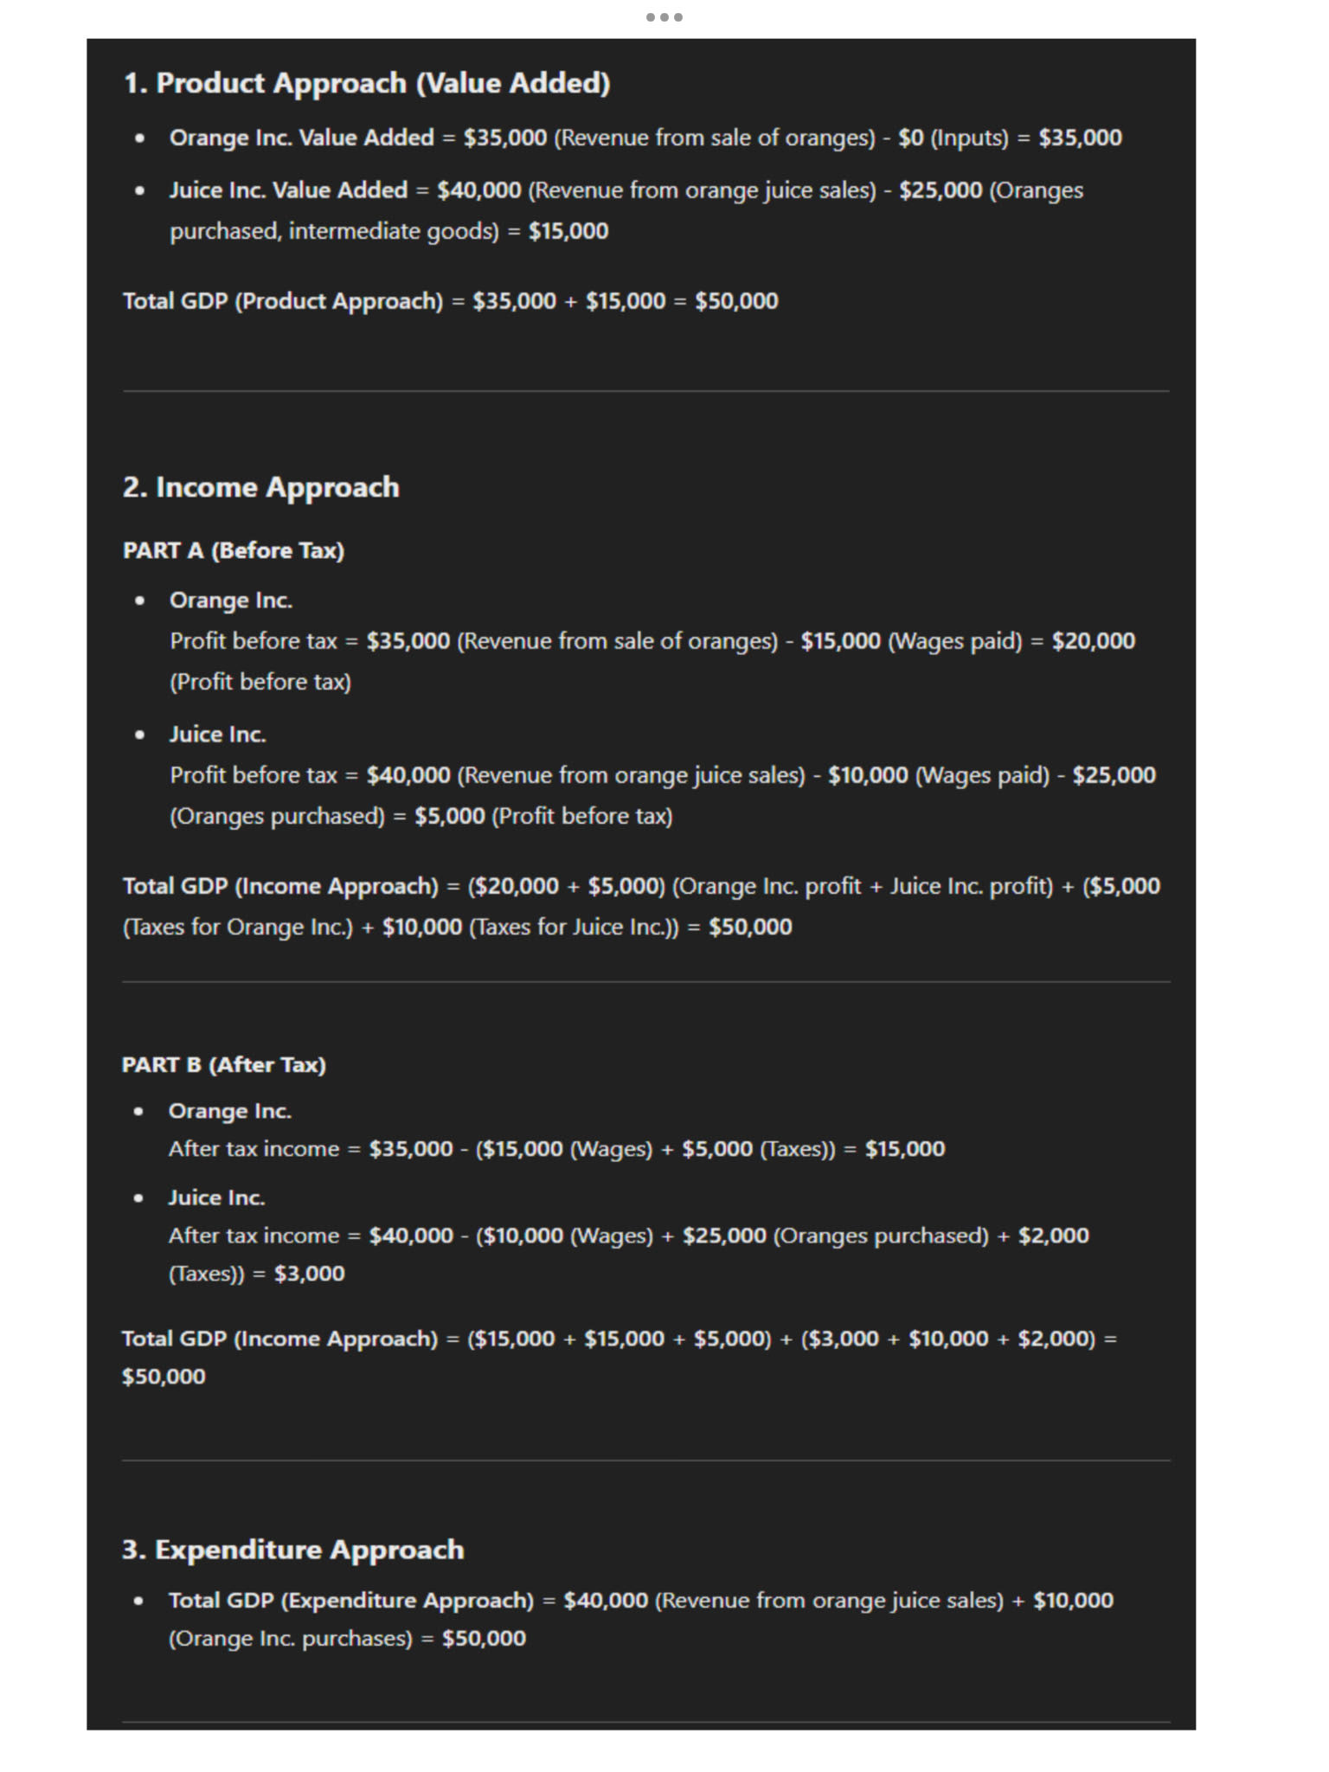

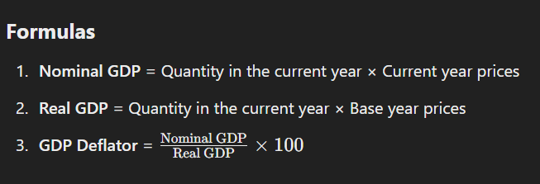
Fruits | Current Year Data |  | Base Year Data
 | Quantity | Price | Quantity | Price
Apples | 4,000 | $3 | 3,000 | $2
Oranges | 14,000 | $2 | 6,000 | $3
Bananas | 32,000 | $5 | 8,000 | $4
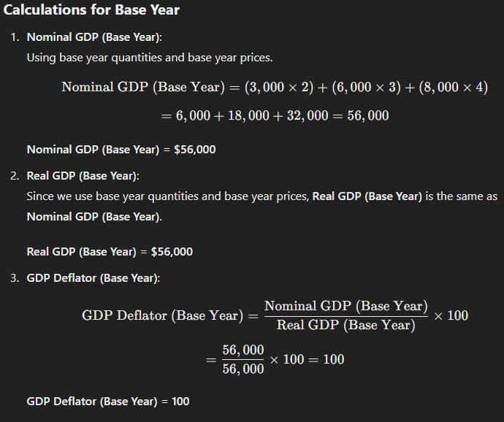
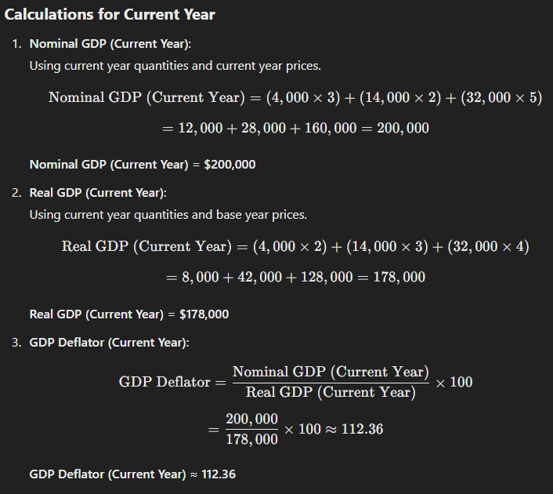
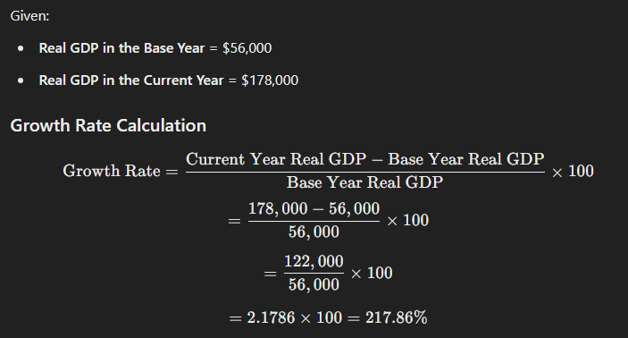

PARABLES OF THE MODERN ECONOMY: An analogy or a story with a lesson
- The farmer produces crops at a low cost while raising animals is cheaper for the rancher.
- By each specializing in what they produce most efficiently, they can trade crops for animals at lower costs than producing both themselves.
- Through specialization and trade, both achieve greater overall consumption and efficiency, demonstrating gains from trade.
ADAM SMITHS THEORY OF ABSOLUTE ADVANTAGE: Countries benefit from specializing in producing goods where they are most efficient (can produce with fewer resources).
Assumptions:
- Factors of Production are Mobile: Resources like labor and capital can move freely across borders.
- Fixed Labor Hours: Labor input remains constant in the production of goods.
- No Government Intervention: Trade occurs without tariffs, subsidies, or other government policies.
- Full Knowledge of Strengths and Weaknesses: Each country knows its production capabilities and limits, allowing it to focus on the goods it produces most efficiently.
Benefit of Specialization: By each country focusing on its absolute advantage, total global output increases, and both countries benefit through trade.

1. Initial Production Setup
 | Country A | Country B
Product X | 2 units | 1 unit
Product Y | 1 unit | 2 units
- Interpretation: With 2 labor hours each, Country A produces 2 units of X and 1 unit of Y, while Country B produces 1 unit of X and 2 units of Y.
- World Production Before Trade:
  - Total X: 2 (A) + 1 (B) = 3
  - Total Y: 1 (A) + 2 (B) = 3
  - World Total Production: 3 + 3 = 6

2. Specialization After Trade
 | Country A | Country B
Product X | 4 units | 0 units
Product Y | 0 units | 4 units
- Explanation: Each country specializes in the product where it has a comparative advantage:
  - Country A specializes in producing X.
  - Country B specializes in producing Y.

3. Terms of Trade (Exchange Rate)
- Exchange Rate: 1 unit of X for 1 unit of Y.
 | Country A | Country B
Product X | 3 units (keeps) + 1 unit (transfers) | 0 units + 1 unit (receives)
Product Y | 0 units + 1 unit (receives) | 3 units (keeps) + 1 unit (transfers)

 | Country A | Country B
Product X | 3 units | 1 unit
Product Y | 1 unit | 3 units

4. Final Allocation After Trade
- World Production After Trade: 8 units (4 X + 4 Y).
- Gains from Trade: 8 (after trade) - 6 (before trade) = 2 units.

Lesson Learned: By specializing according to comparative advantage and trading, both countries benefit, achieving a higher combined output than if they produced independently.
CIRCULAR INCOME FLOW
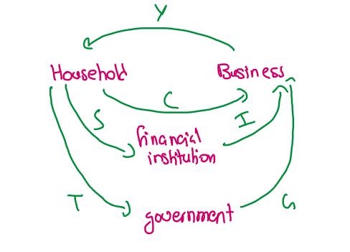

Component | Formula | Explanation
Total Income (Y) | Y = C + I + G | Total income is the sum of consumption (C), investment (I), and government spending (G) in a closed economy. (Equilibrium Condition)
Consumption (C) | C = a + (b ⋅ Yd) | Consumption depends on autonomous consumption (a​) and the marginal propensity to consume (b) times disposable income (Yd​).
Disposable Income (Yd) | Yd = Y − T | Disposable income is the total income minus taxes (T).
Taxes (T) | T = T0 + (t ⋅ Y) | Taxes consist of autonomous taxes (T0​) and a proportional tax rate (t) times income (Y).
Savings (S) | S = − a + ((1−b) ⋅ Yd​) | Savings are autonomous savings (−a) plus the marginal propensity to save (1−b) times disposable income.
Marginal Propensity to Consume (MPC) | b = ΔC / ΔYd | Marginal propensity to consume is the change in consumption divided by the change in disposable income.
Marginal Propensity to Save (MPS) | (1−b) = ΔS / ΔYd | Marginal propensity to save is the change in savings divided by the change in disposable income. (MPC + MPS = 1)
Total Output (GDP) | Y = C + S + T | Total output is the sum of consumption, savings, and taxes in the economy.

MULTIPLIER (INJECTION)
- The multiplier is the ratio of change in total income (GDP) to the initial change in autonomous expenditure, indicating how much income increases for each unit increase in spending.
- The multiplier is the ratio of the change in equilibrium income to the initial increase in spending or injection into the economy.
- Multiplier Effect: The multiplier effect refers to the "ripple effect" where an initial increase in spending (investment or government spending) leads to a larger increase in equilibrium income.
- Types of Multiplier Effects:
  - Government Spending Multiplier: An increase in government spending leads to a larger increase in income.
  - Investment Multiplier: An increase in investment leads to an increase in income.
  - Tax Multiplier: A change in taxes affects disposable income and, in turn, consumption and saving behavior.
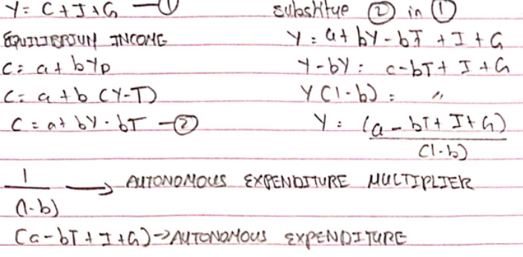
- Fractional Banking: Fractional banking operates based on the multiplier effect, where banks only need to keep a fraction of deposits as reserves, and can lend out the rest. The total money supply expands due to the lending process.

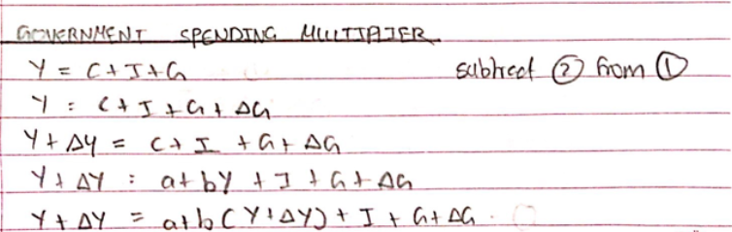
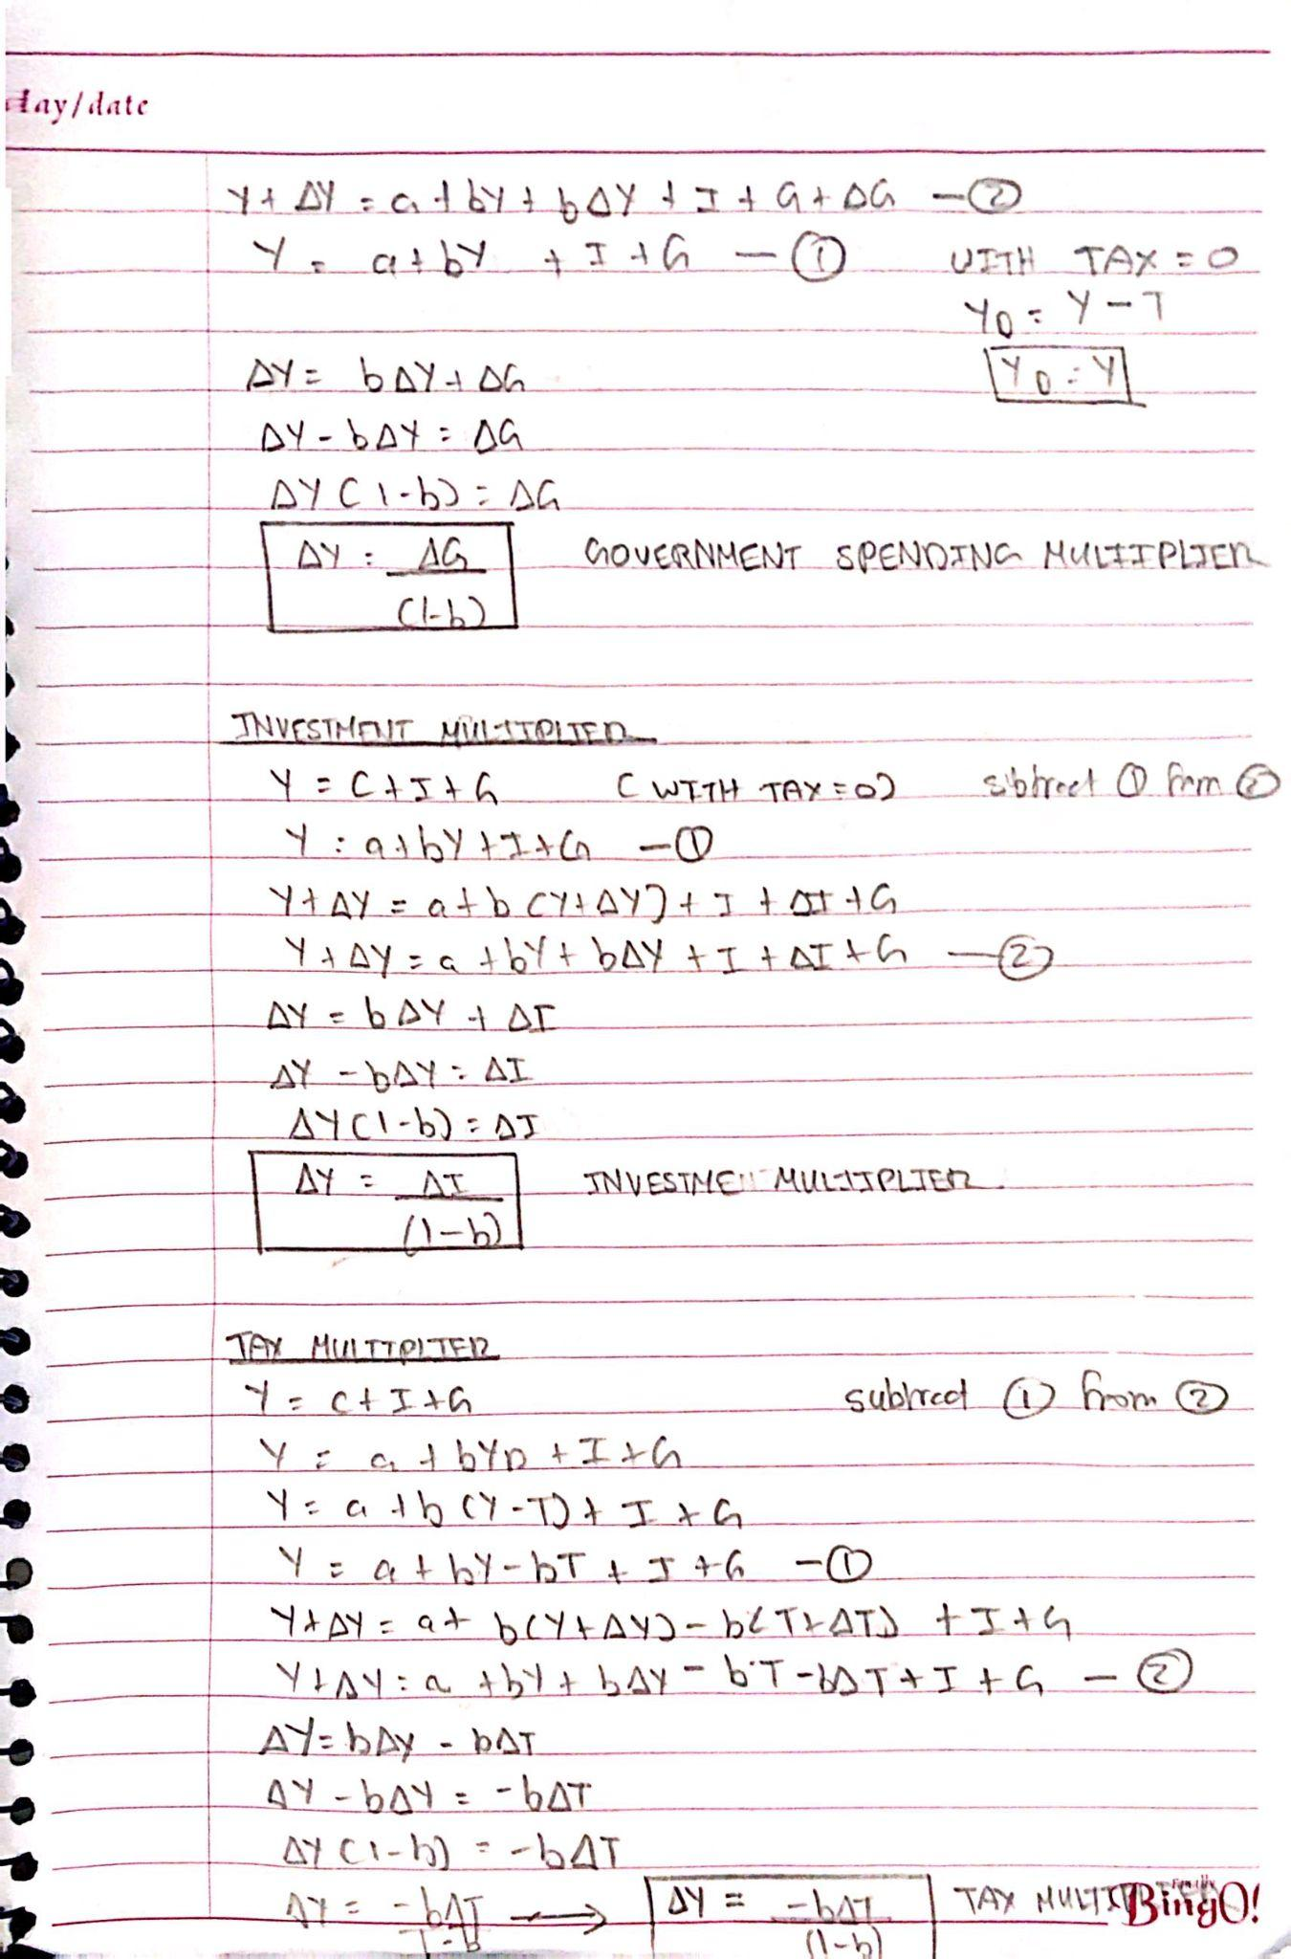

LECTURE THIRTEEN
MONEY AND BANKING
Money is anything widely accepted for payment of goods, services, or settlement of debts.

Money Equation:
Money = Currency + Coins + Bills + Debit Cards + Credit Cards + Online Payments

Functions of Money:
- Medium of Exchange: Facilitates transactions by eliminating the need for a barter system (direct exchange of goods and services), which suffers from the problem of double coincidence of wants. Money solves this by being universally accepted.
- Unit of Account: Money serves as a yardstick to measure the value of goods and services. It allows for consistent pricing and valuation, enabling comparisons. For example, if you have 10 goods, the formula n(n-1)/2 can be applied to measure the value relationships between goods.
- Store of Value: Money retains its value over time, allowing it to store purchasing power and liquidity for future use. It ensures wealth can be preserved for future transactions.
- Standard of Deferred Payment: Money is used to settle debts in the future, providing a common basis for future payments and agreements.
WWII PRISONERS OF WAR AND BARTER SYSTEM
During World War II, prisoners of war (POWs) in extreme conditions, particularly in prisoner camps, often relied on supplies from the Red Cross such as shirts, shoes, cigarettes, and chocolate. These items were vital for survival and, over time, soldiers developed their own informal system of exchange to trade goods.
Cigarettes as Currency: Cigarettes became the primary medium of exchange in these POW camps for several reasons:
- Medium of Exchange: Widely available, easily traded for food, clothing, and supplies.
- Unit of Account: Used to value goods (e.g., a set number of cigarettes for food).
- Store of Value: Durable, portable, non-perishable, held value over time.
- Standard of Deferred Payment: Allowed for settling debts later, with cigarettes.
Cigarettes met all functions of money, becoming an effective currency in POW camps.
NEAR-MONIES (MONETARY AGGREGATES):
M1 = Currency + Coins + Demand Deposits
M2 = M1 + Eurobonds + Traveler's Checks + Small-Time Deposits + Purchase Agreements + Savings + Mutual Funds
M3 = M2 + Large-Time Deposits + Long-Term Savings
- Demand Deposits: Current account balances that can be accessed immediately.
- Eurodollars: Dollar-denominated deposits held outside the U.S. (e.g., in foreign banks).
- Residential Foreign Currency Deposits: Deposits held in foreign currencies by residents in other countries.
- Small-Time Deposits: Deposits placed for less than 5 years, such as PLS savings accounts.
- Repurchase Agreements: Short-term loans using T-Bills as collateral, where one party sells securities with the agreement to repurchase them.
- Treasury Bills (T-Bills): Short-term government securities issued by the central bank with maturities of 3, 6, or 12 months. They are sold at a discount and redeemed at face value upon maturity, with the difference representing the investor's earnings
- Long-Term Savings: Investments like bonds and stocks that are intended for extended periods to provide higher returns.
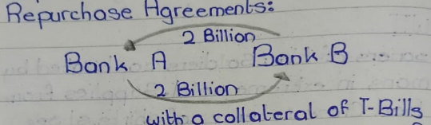
- Mutual Fund: A collective pool of savings invested in profitable ventures, managed by financial institutions with the investors' consent.

BASICS OF BANKING - A MODEL OF MONEY SUPPLY

In basic banking, the balance sheet of a bank is divided into assets and liabilities:
- Liabilities (Deposits):
These include the money customers deposit in the bank, such as in savings accounts or current accounts. For the bank, these deposits are liabilities because the bank owes this money back to the customers.
- Assets (Reserves and Loans):
- To protect customers’ deposits, banks must hold reserves (backup cash so that the bank can return our money at any time). Reserves are part of the bank’s assets and include:
  - Cash in the vault or ATMs.
  - Deposits with the central bank (e.g., Federal Reserve, State Bank).
Beyond reserves, banks use part of the deposits to provide loans or make investments, which also count as assets because they generate income for the bank (e.g., interest).
The bank ensures that a certain percentage of deposits (reserves) is always accessible to meet withdrawal demands. These reserves act as a protective layer for depositors’ money.
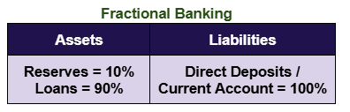
100% Reserved Banking
Assets | Liabilities
Reserves (RR)  = 100% | Direct Deposits / Current Account = 100%

100% Reserved Banking
- Assets (Reserves): In a 100% reserve banking system, banks are required to keep the full amount of all deposits as reserves. For every unit of deposit in the current account, there is an equivalent unit in the bank's reserves (e.g., cash or central bank reserves).
- Liabilities (Deposits/Current Account): The deposits are entirely backed by these reserves. Banks cannot lend out the money deposited in current accounts, ensuring depositors' funds are always available for withdrawal.
Customers can deposit and withdraw at any time and the bank charges a basic fee

Fractional Reserve Banking
- Assets (Reserves): In fractional reserve banking, banks only keep a fraction of deposits as reserves. The reserve ratio is determined by regulations (e.g., 10%). The remainder of the deposits can be lent out or used to invest in assets by the bank to earn a profit.
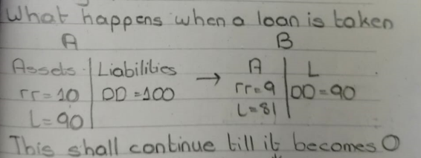
- Liabilities (Deposits/Current Account): Although not all deposits are backed by reserves, banks rely on the assumption that not all depositors will withdraw their funds simultaneously. This system allows banks to create money through the lending process, increasing the money supply.
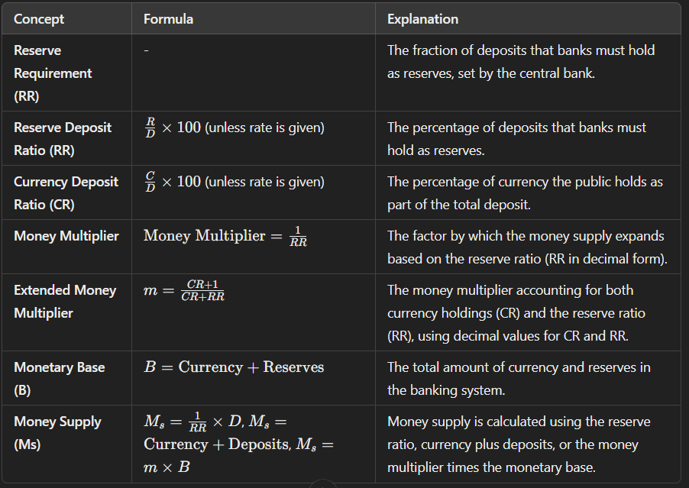

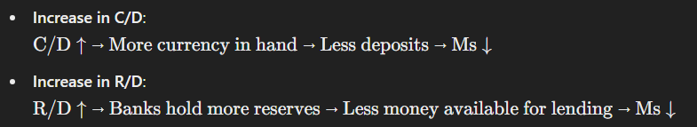

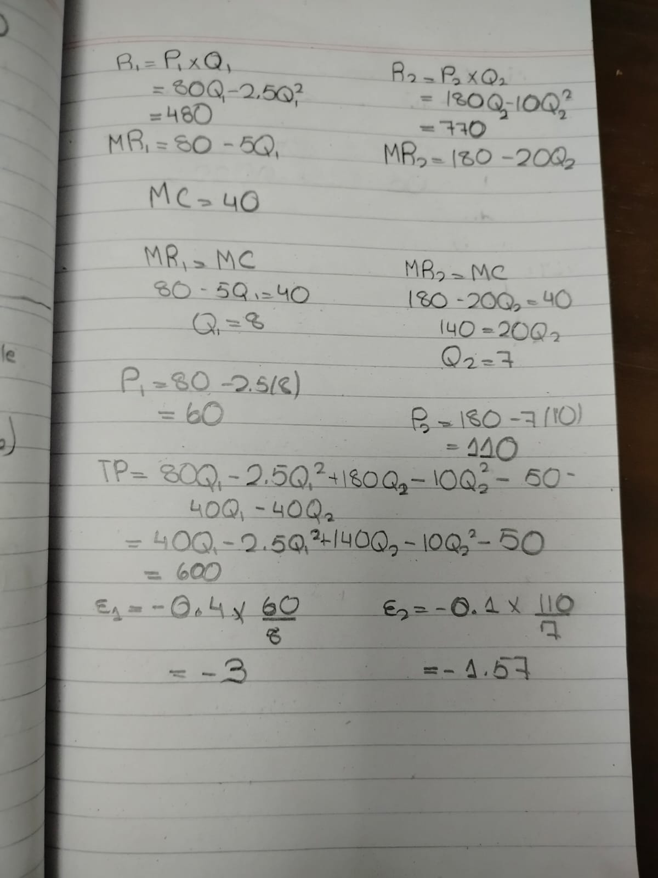
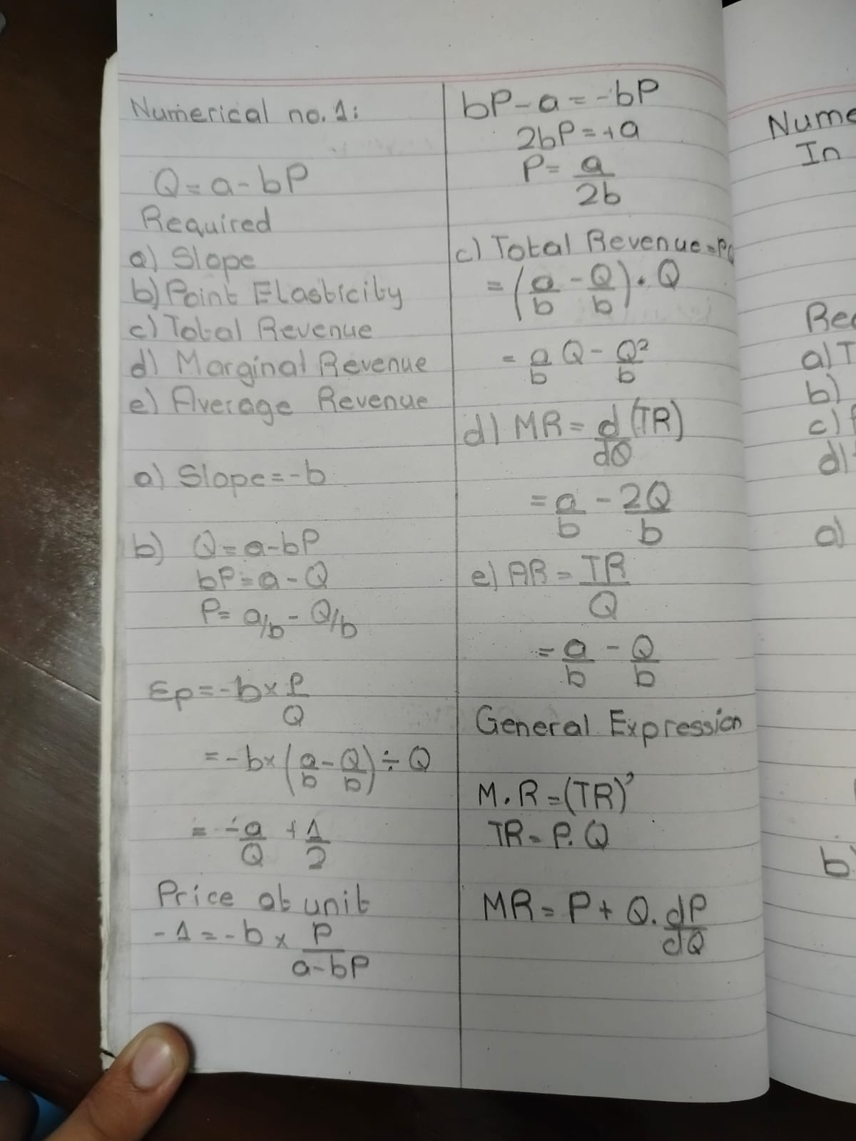
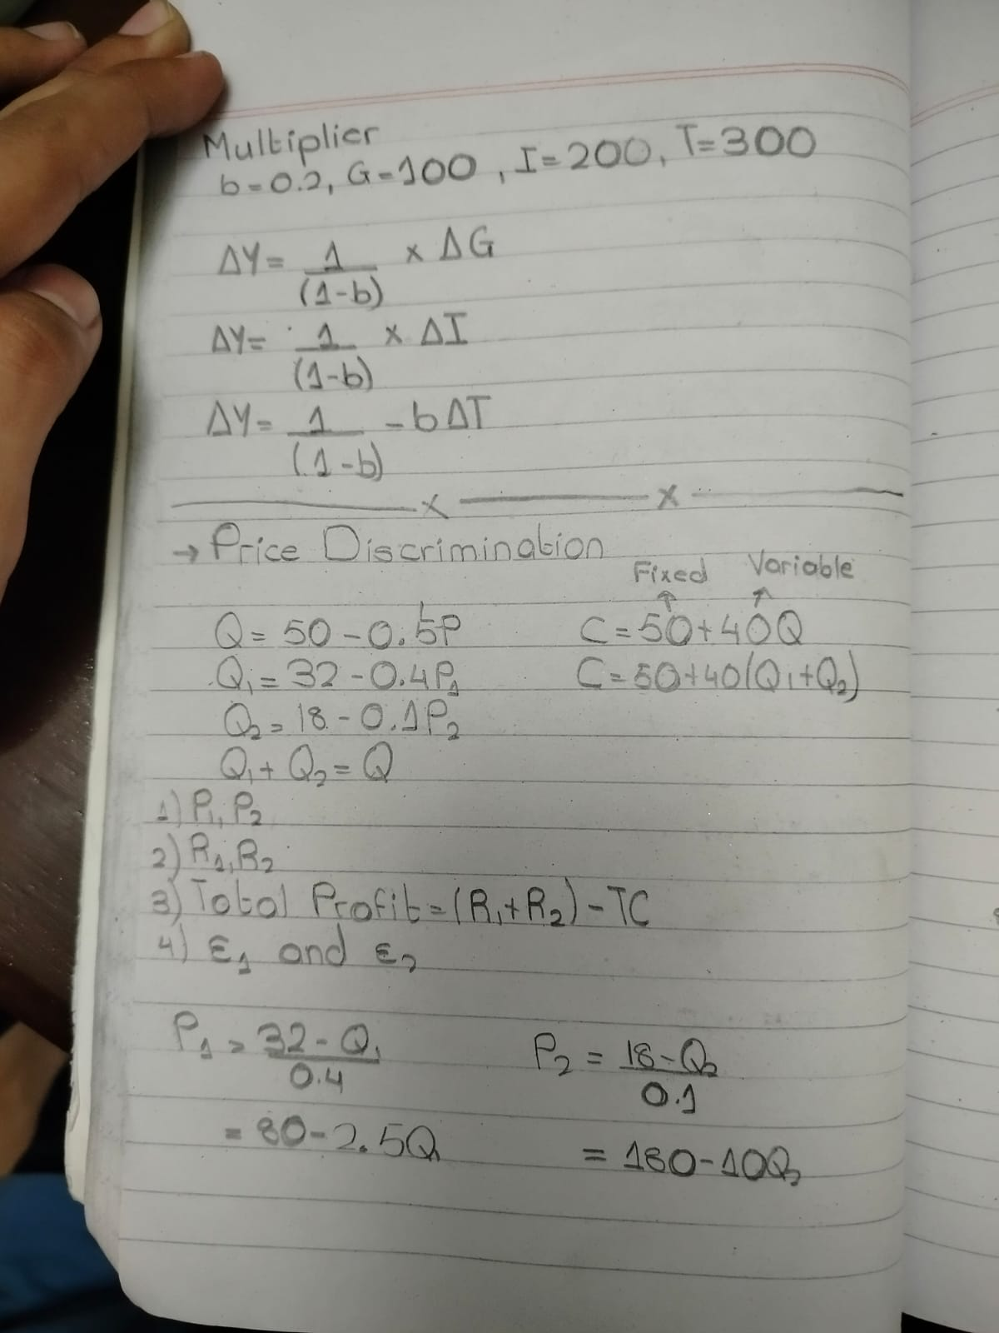
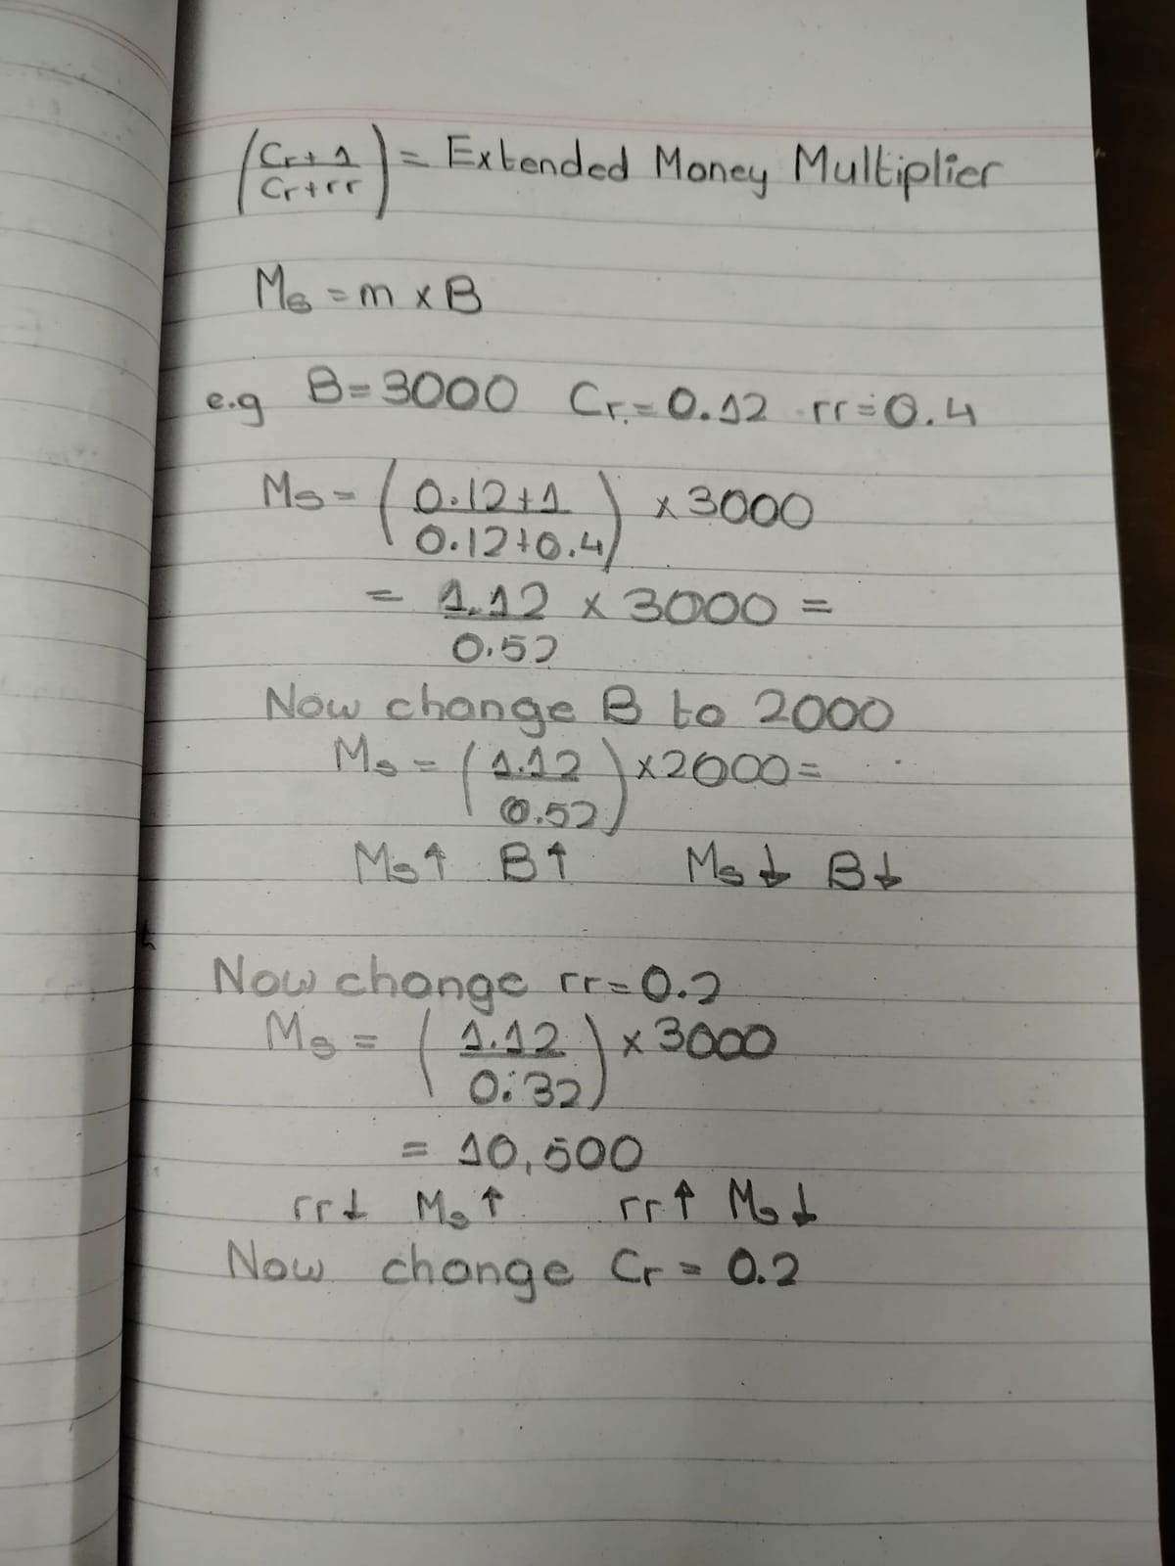
LECTURE FOURTEEN
